Assignment Two Report

Yang Tong A01011328

Contents

1. Requirement satisfied 3

2. Entity Relationship Diagram 4

4. Detailed Design 6

5. Form Images 10

6. Test Plan and Test Case 13

7. Test Results 21

8. database setting 21

9. Instructions for Building and Running 22

## Requirement satisfied

In our program, there is a login page allows you to login as administrator or user. As an administrator, you can manage users, such like create new user, see and change user’s data, or even delete users. As a user, you have your own employee number and you can change your password. User can also create , view, update, and delete their timesheets. When users edit their timesheets, they can add rows, delete rows, and fill content in all fields.

The program using conversation scope, when the employee login, conversation start, when employee logout the conversation end.

## Entity Relationship Diagram

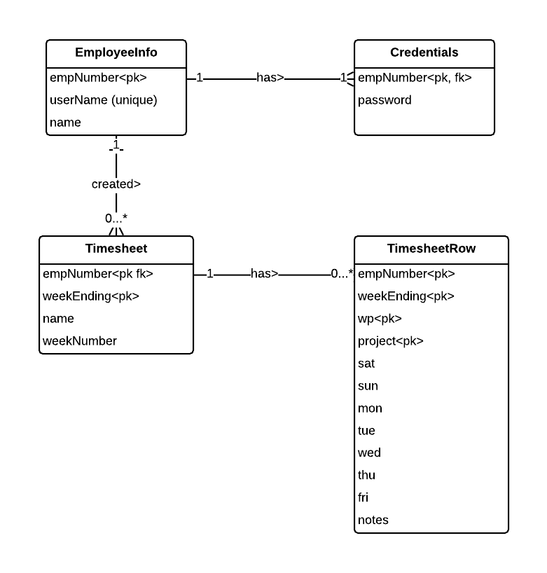

1. **Database Table**

EmployeeInfo

|  |  |  |
| --- | --- | --- |
| empNumber | Int(10) | unique |
| userName | Varchar(20) | Primary key |
| name | Varchar(20) |  |

Credentials

|  |  |  |
| --- | --- | --- |
| userName | Varchar(20) | Paimary key, foreign key(Employeeinfo(empNumber)) |
| password | Varchar(20) |  |

Timesheet

|  |  |  |
| --- | --- | --- |
| empNumber | Int(10) | Paimary key |
| name | varchar(20) |  |
| weekNumber | Int(5) |  |
| weekEnding | date | Paimary key |

TimesheetRow

|  |  |  |
| --- | --- | --- |
| empNumber | Int(10) | Paimary key |
| weekEnding | date | Paimary key |
| wp | Varchar(20) | Paimary key |
| project | Int(10) |  |
| sat | Decimal(3, 1) |  |
| sun | Decimal(3, 1) |  |
| mon | Decimal(3, 1) |  |
| tue | Decimal(3, 1) |  |
| wed | Decimal(3, 1) |  |
| thu | Decimal(3, 1) |  |
| fri | Decimal(3, 1) |  |
| notes | Varchar(2000) |  |

## Detailed Design

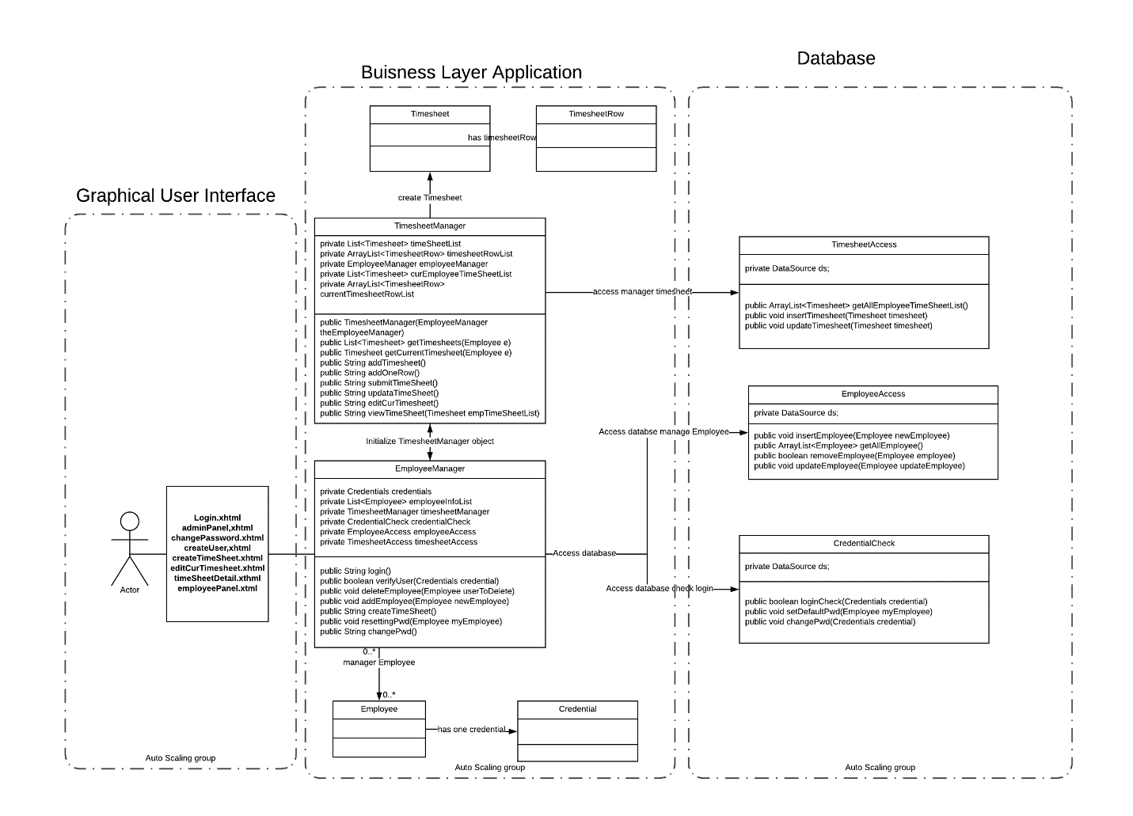

1. Graphical User Interface

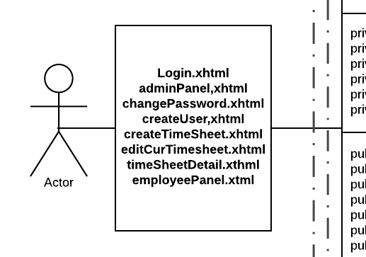

1. Buisness Layer Application

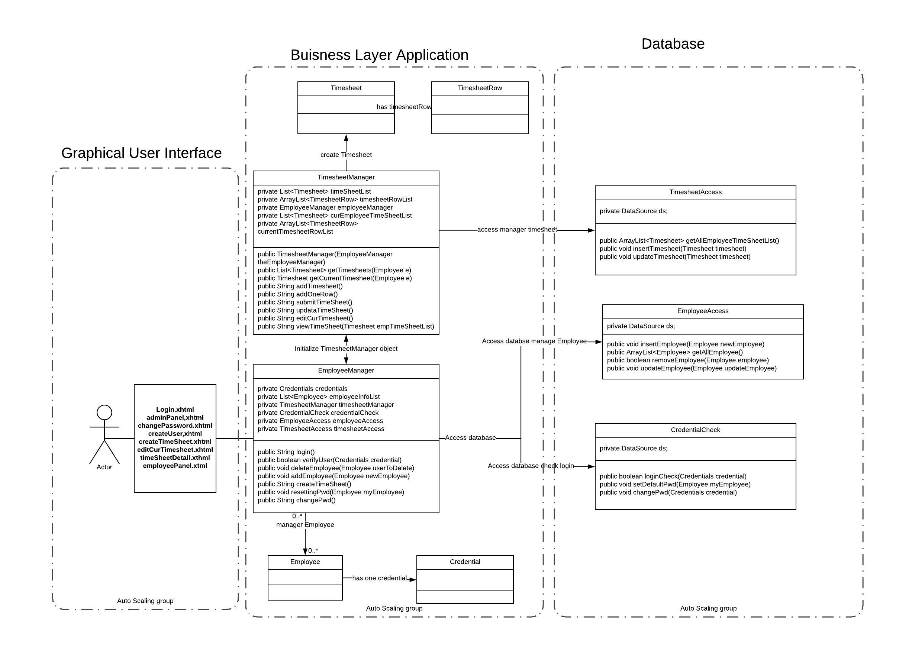

1. Database Access

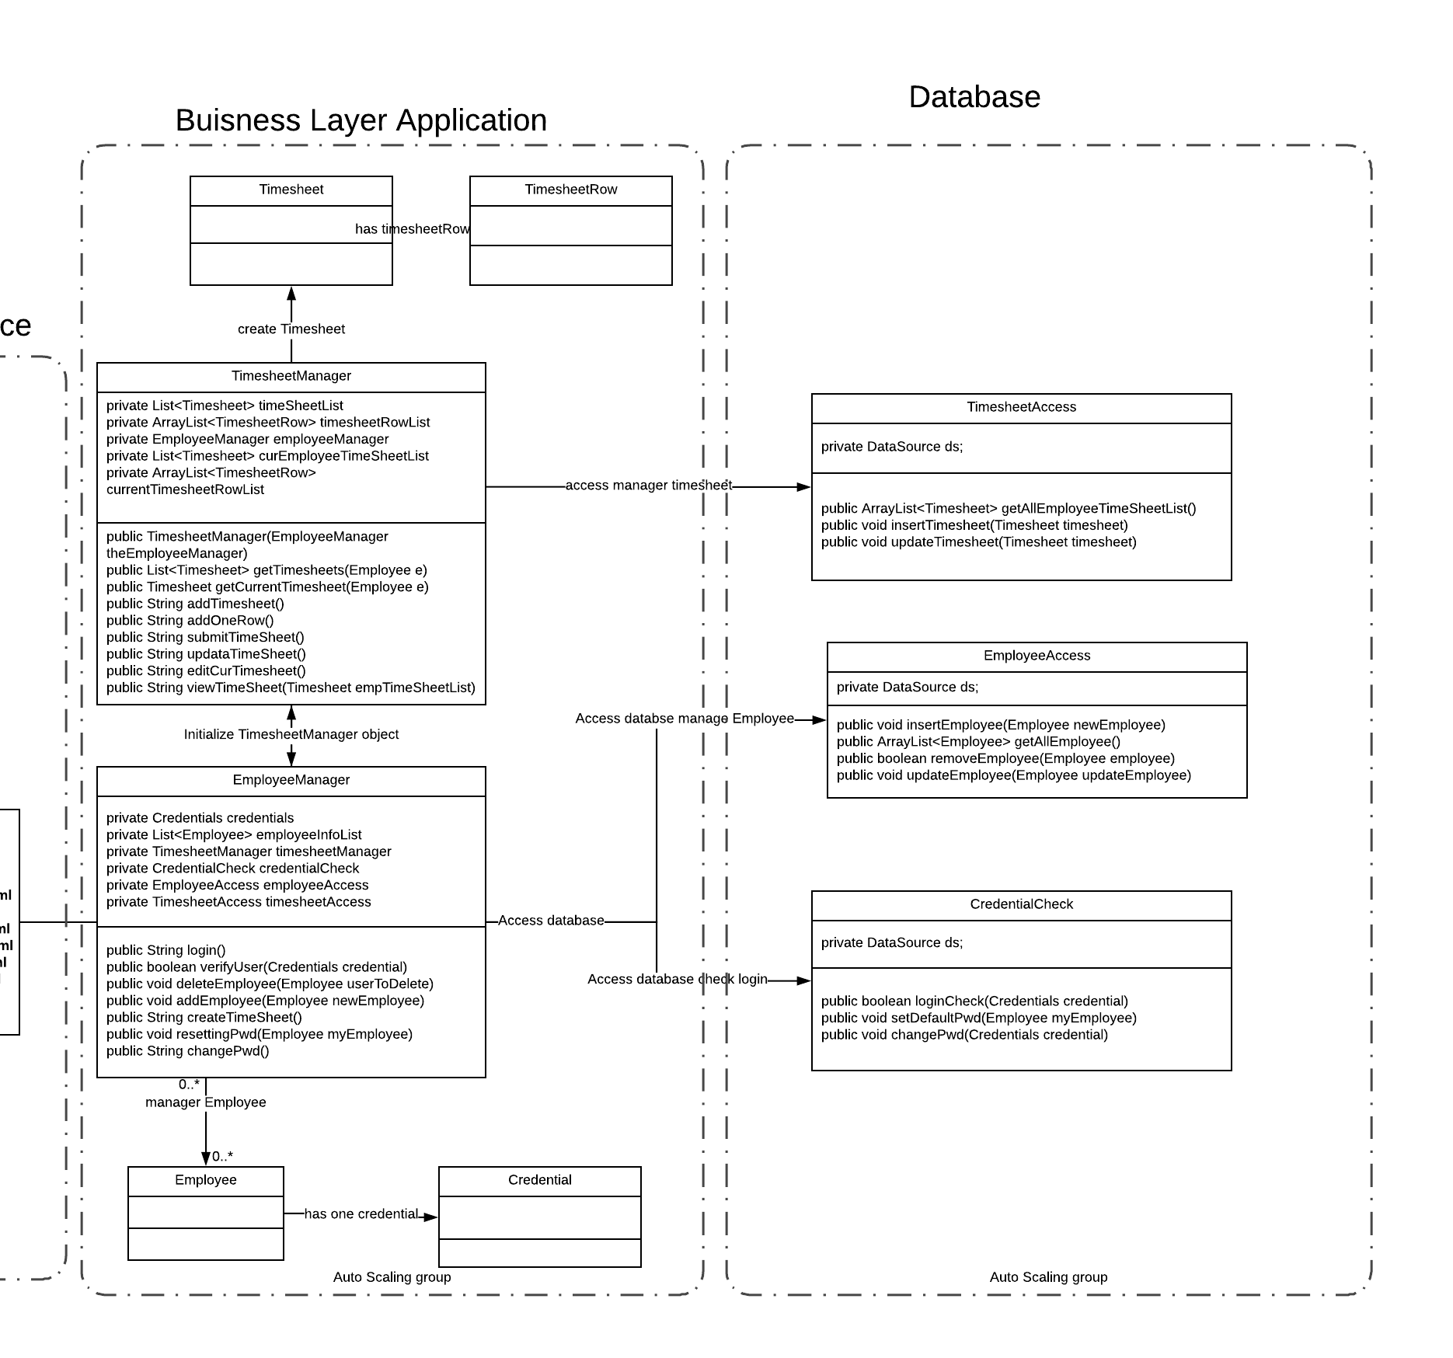

The main page is login, use can login in the main page. The administrator name is admin and pass word is 000000. Defaul password for employee is 000000. Once create employee account, the emplyee can login with their employee account.

There will be two main panel, which is admin panel, and employee panel.

In admin panel, the admin can create, update, delete , read employee information.

In employee panel, the employee can create timesheet, edit current timesheet, and view all timesheet which employee created.

The employee and admin can logout when they finsih their operation.

Basic the manage system using object oriention design. EmployeeManager class contral all thing include login, create timeshee etc... the class owe TimesheetManger which can control and built timesheet.

## Form Images

1. Login page

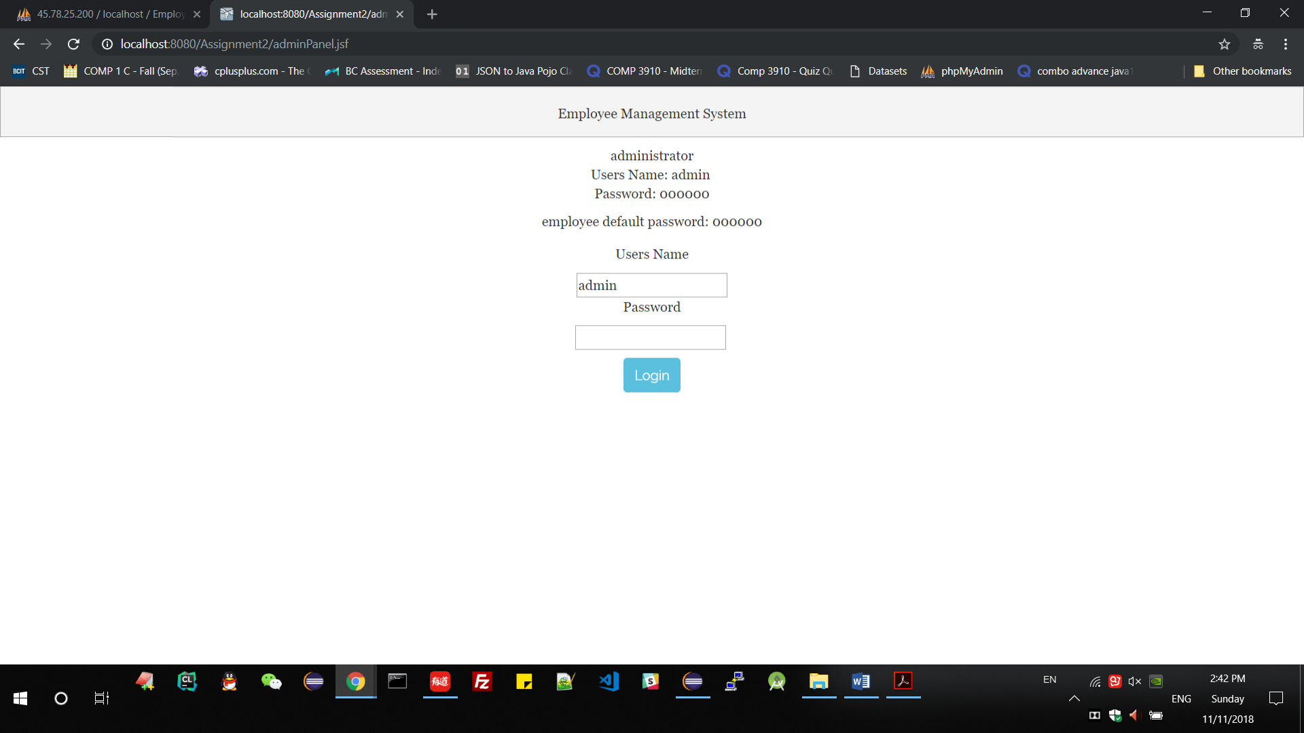

1. Admin Panel Page

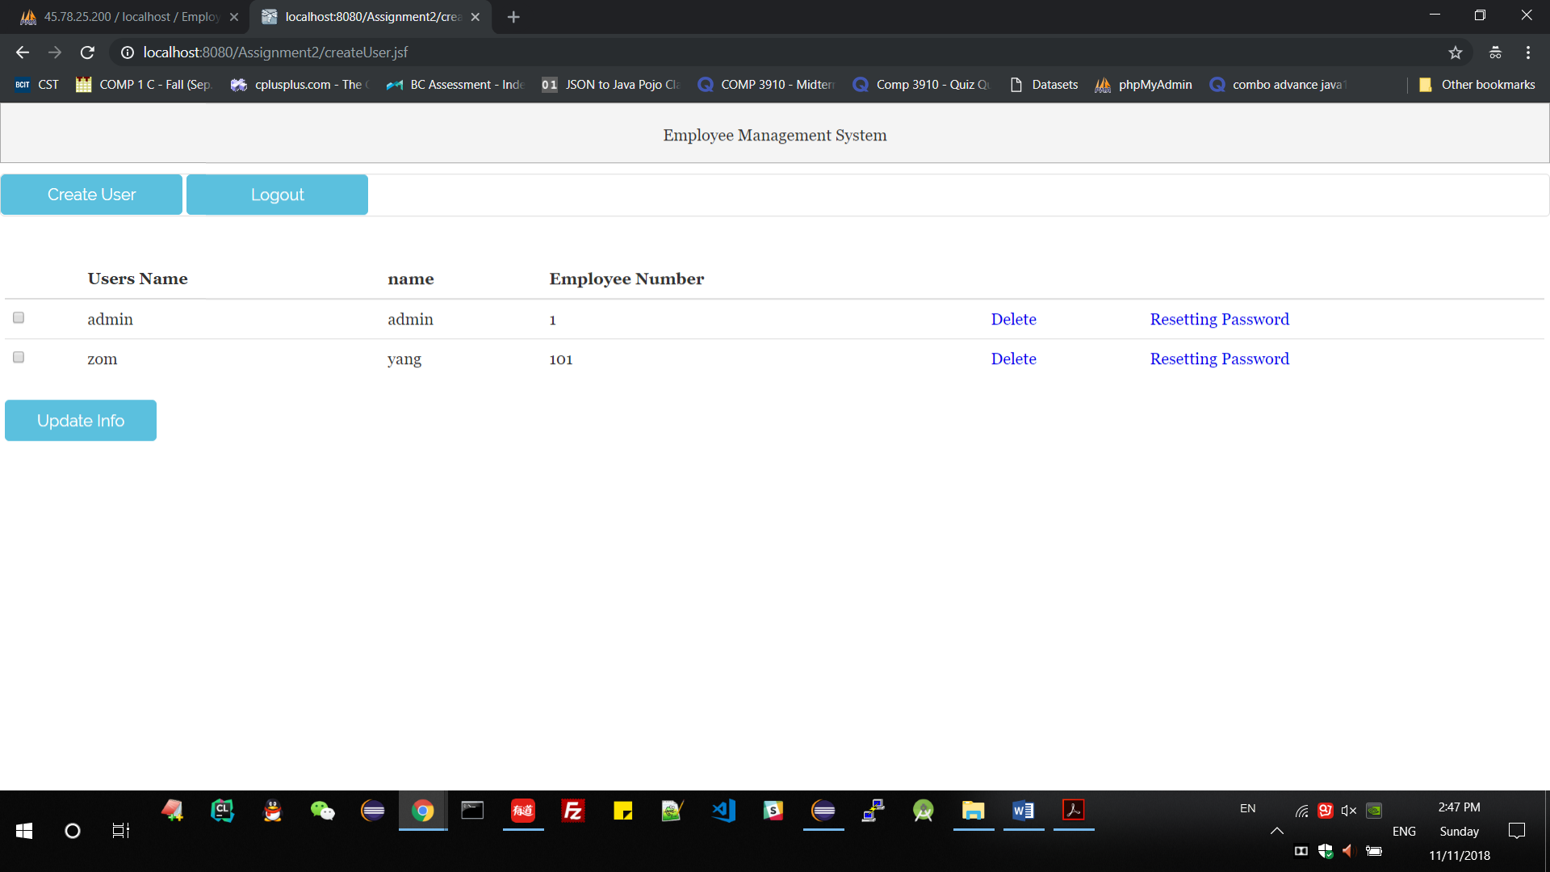

Database Table Data

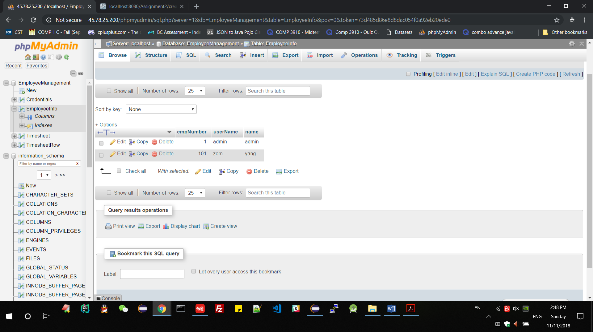

1. Create User(Employee) Page

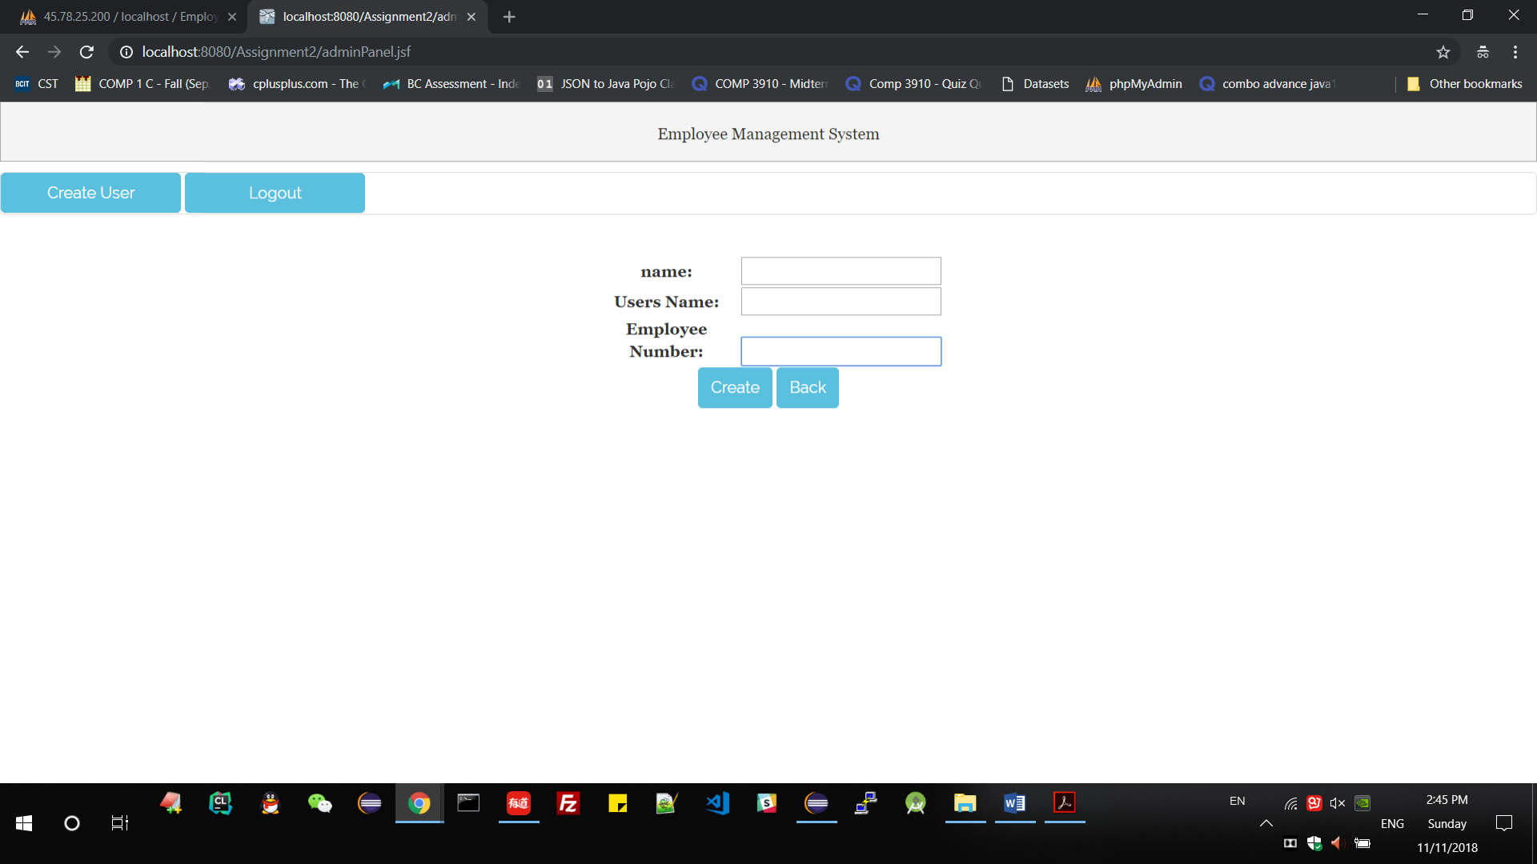

1. Edit User(Employee) Info

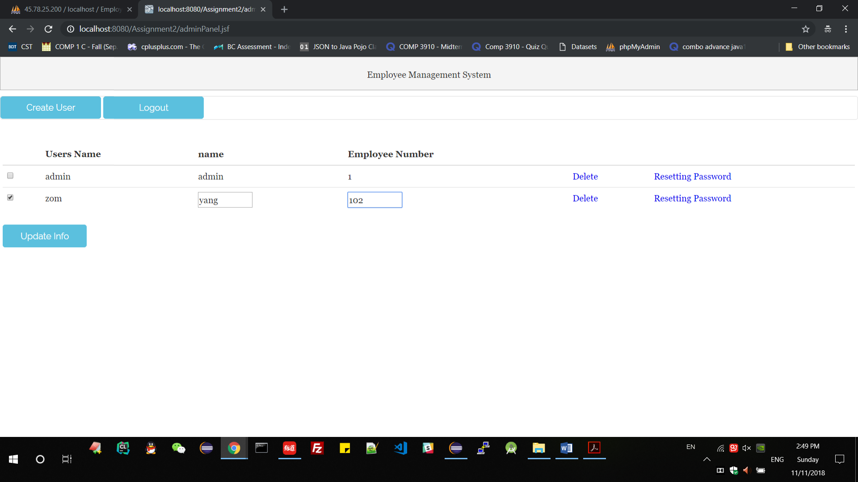

1. Employee Panel

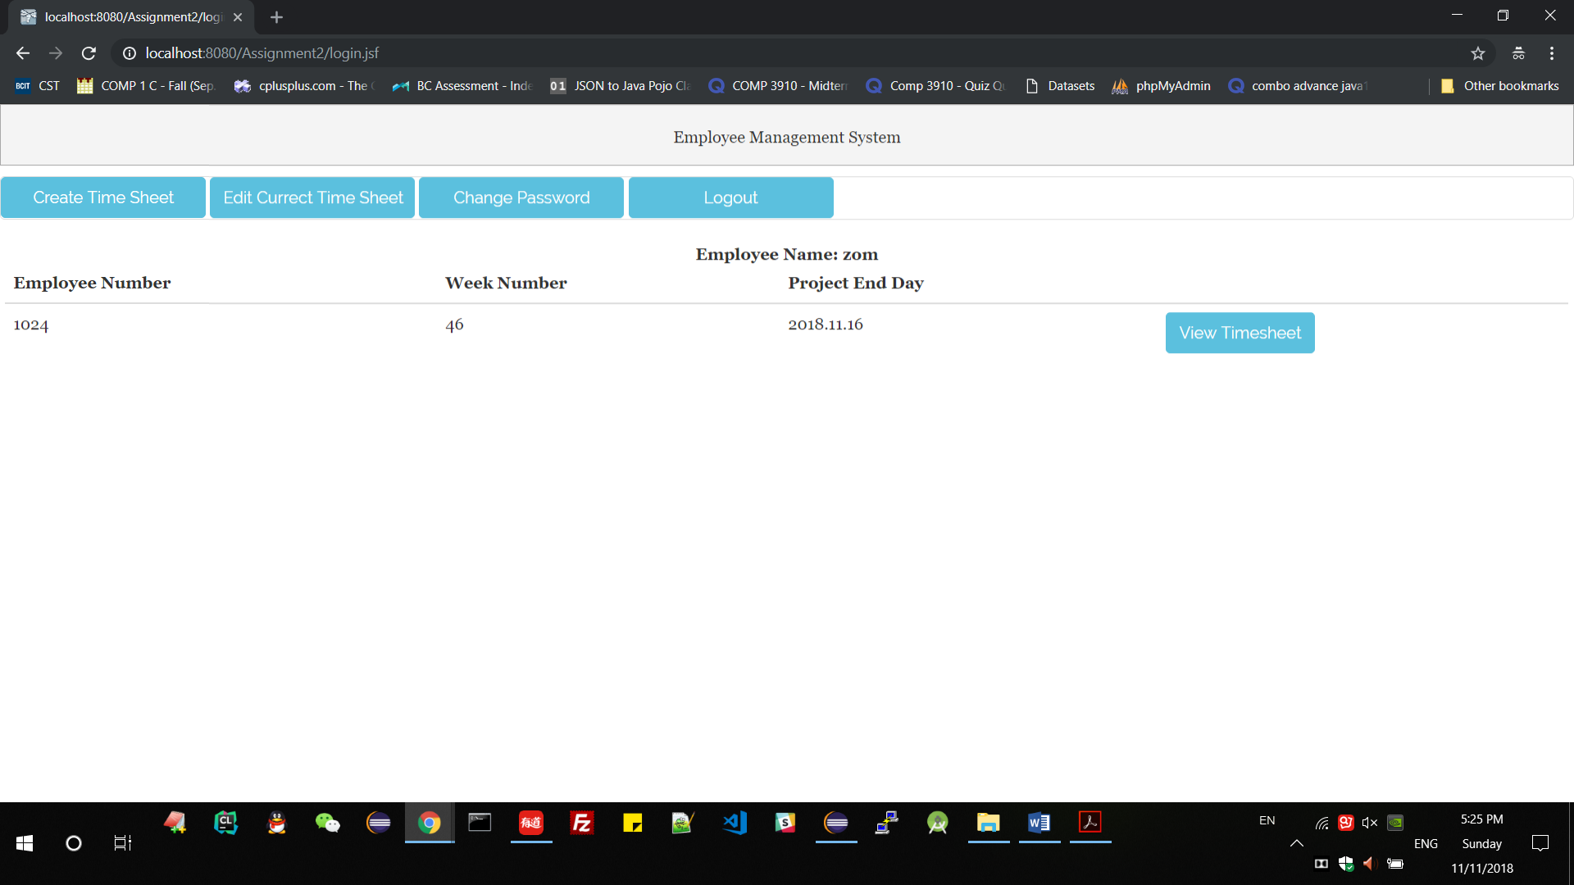

1. Create Timesheet and Add One Row

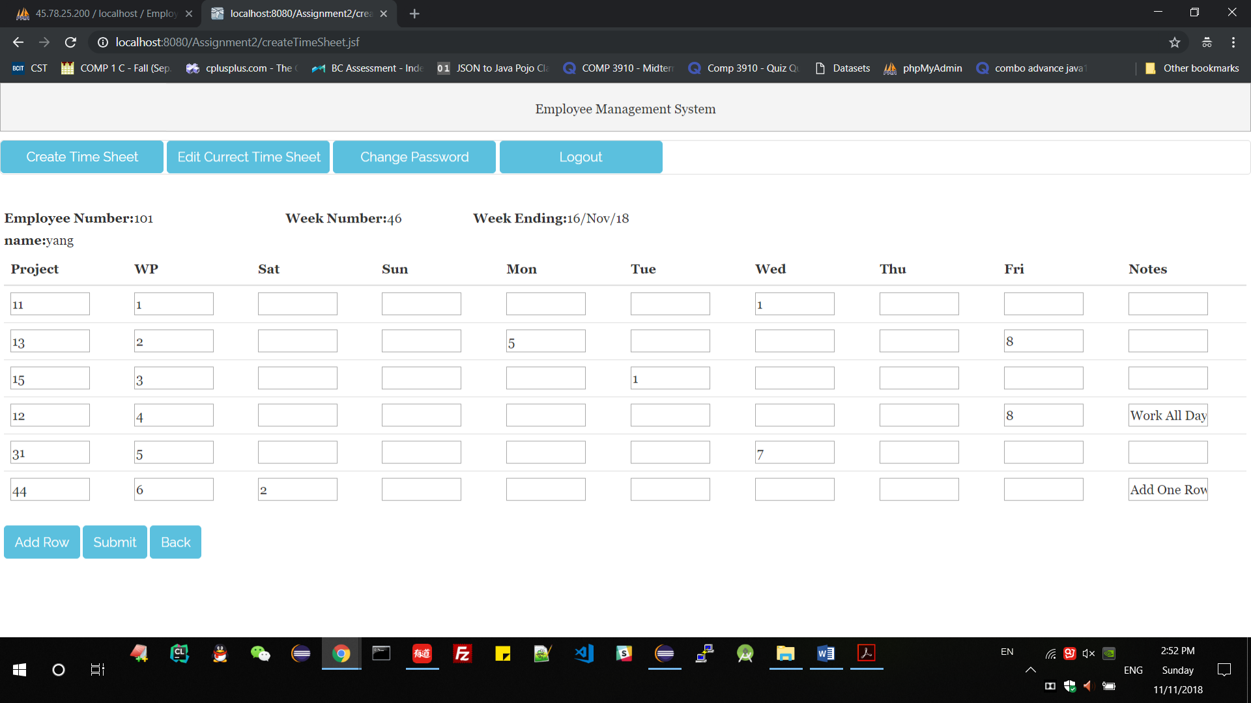

1. Edit Current Timesheet

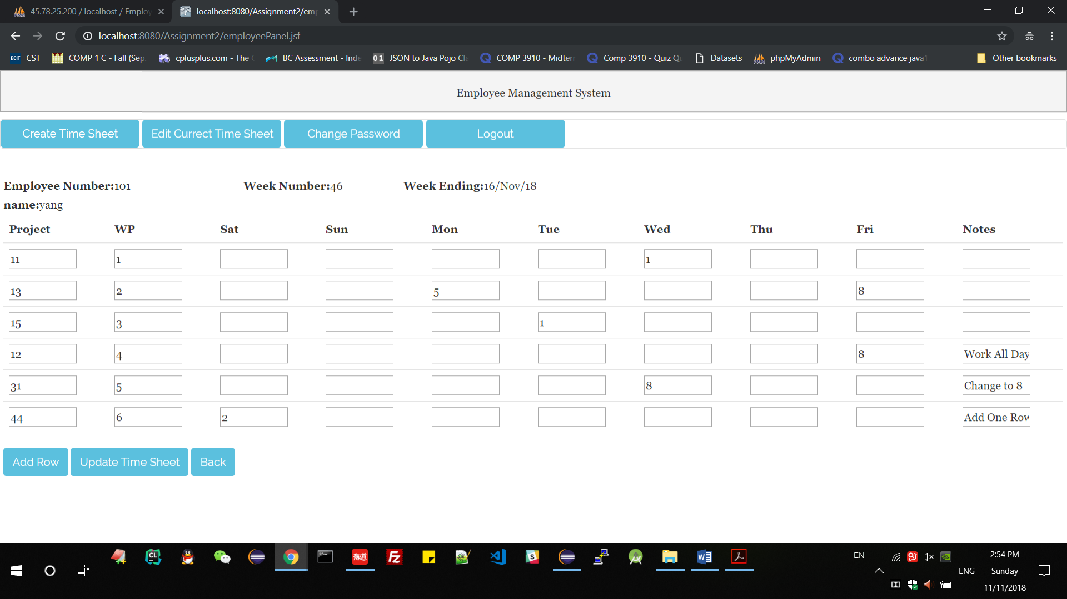

1. View Timesheet Details

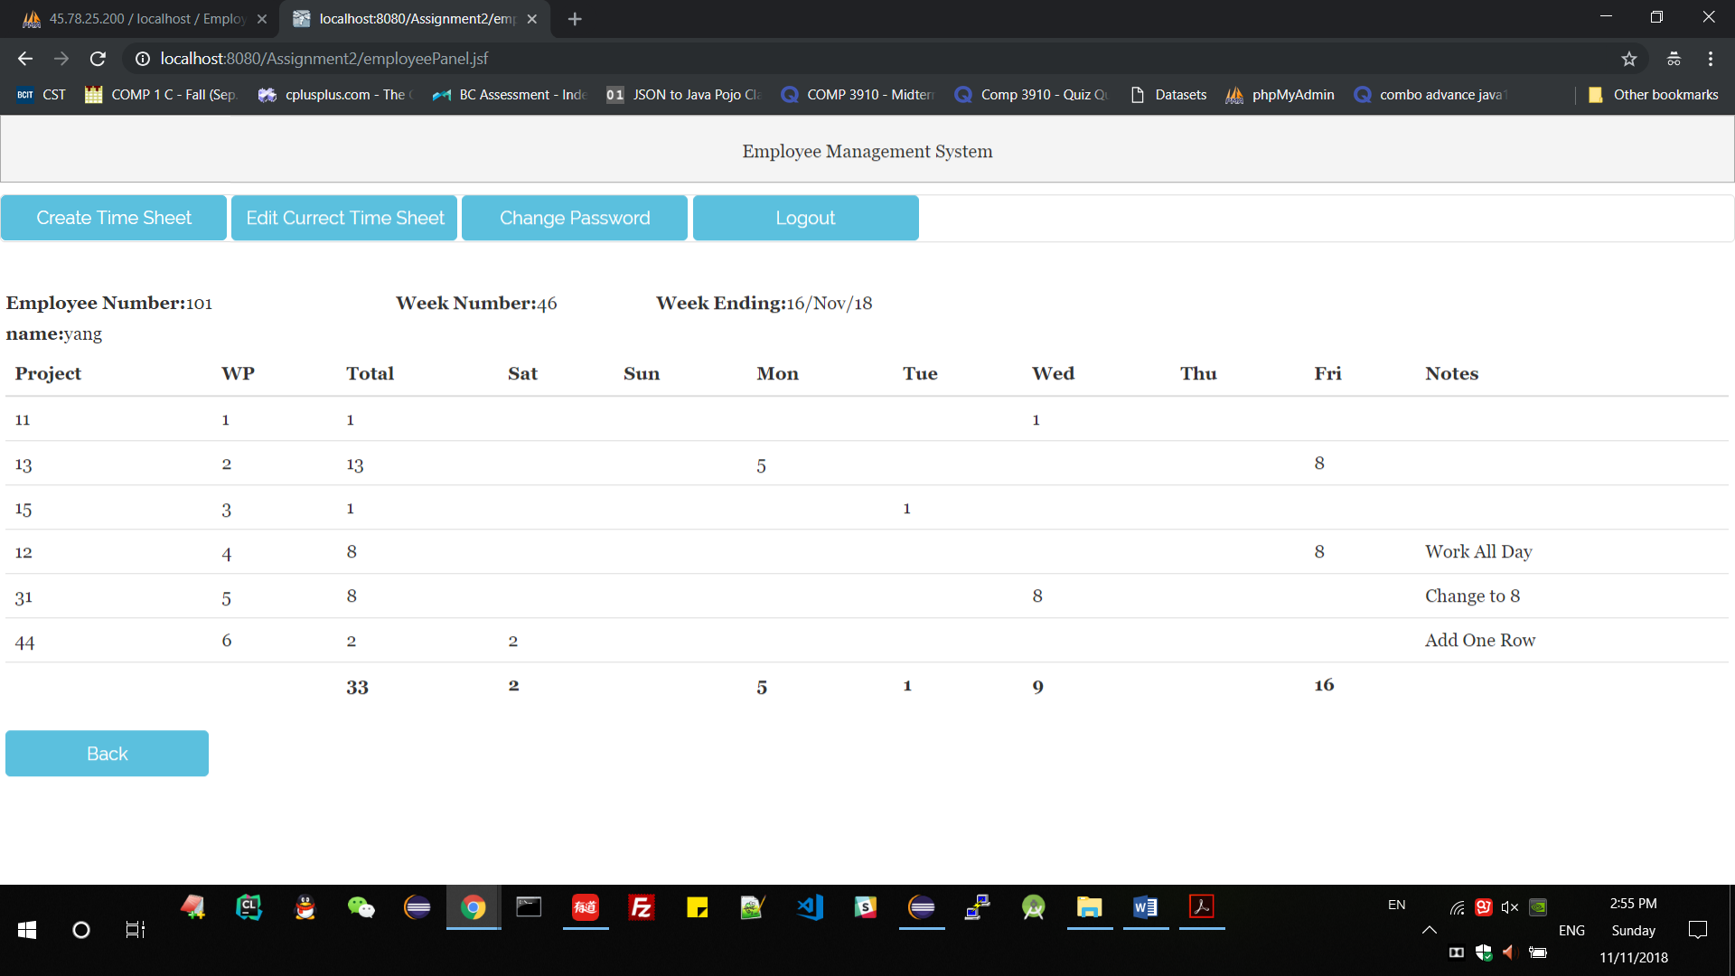

1. Change Password

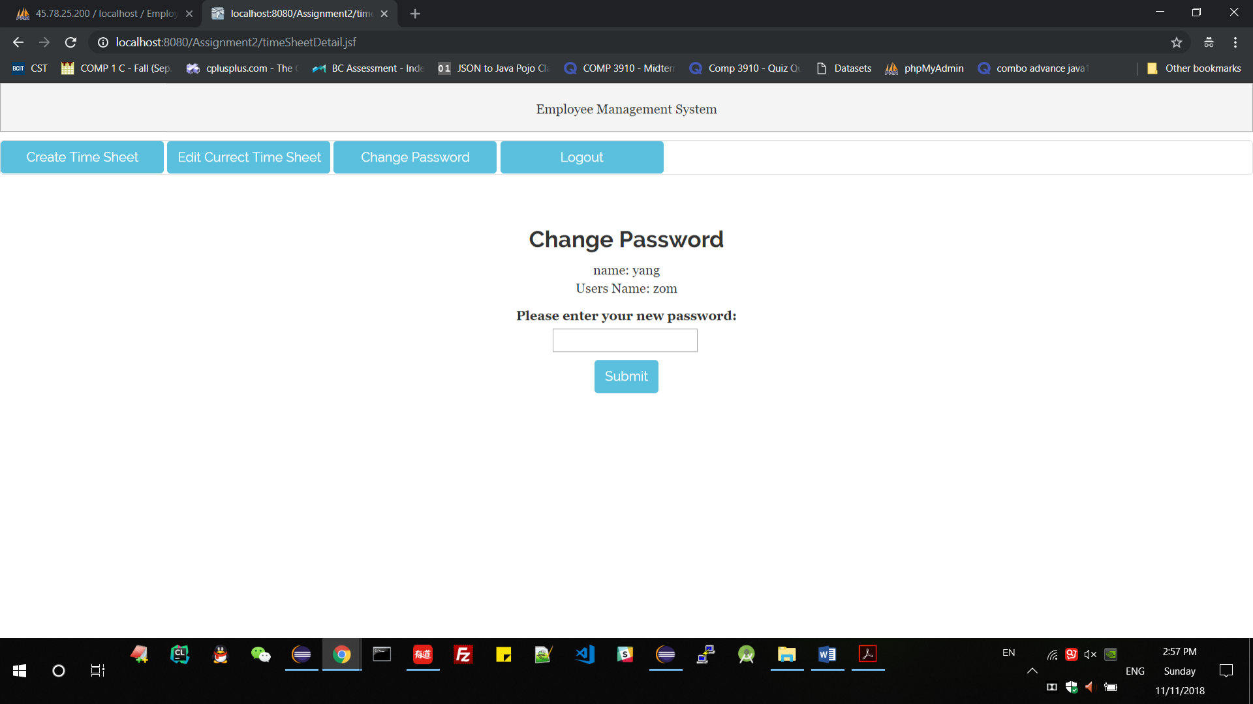

## Test Plan and Test Case

1. Login
2. Login as administrator (the administrator account: admin, password: 000000)

If login success which will direct go to admin panel, if username or password wrong, will give information(user name or password is wrong).

Password is wrong-login failed Password is right-Login success

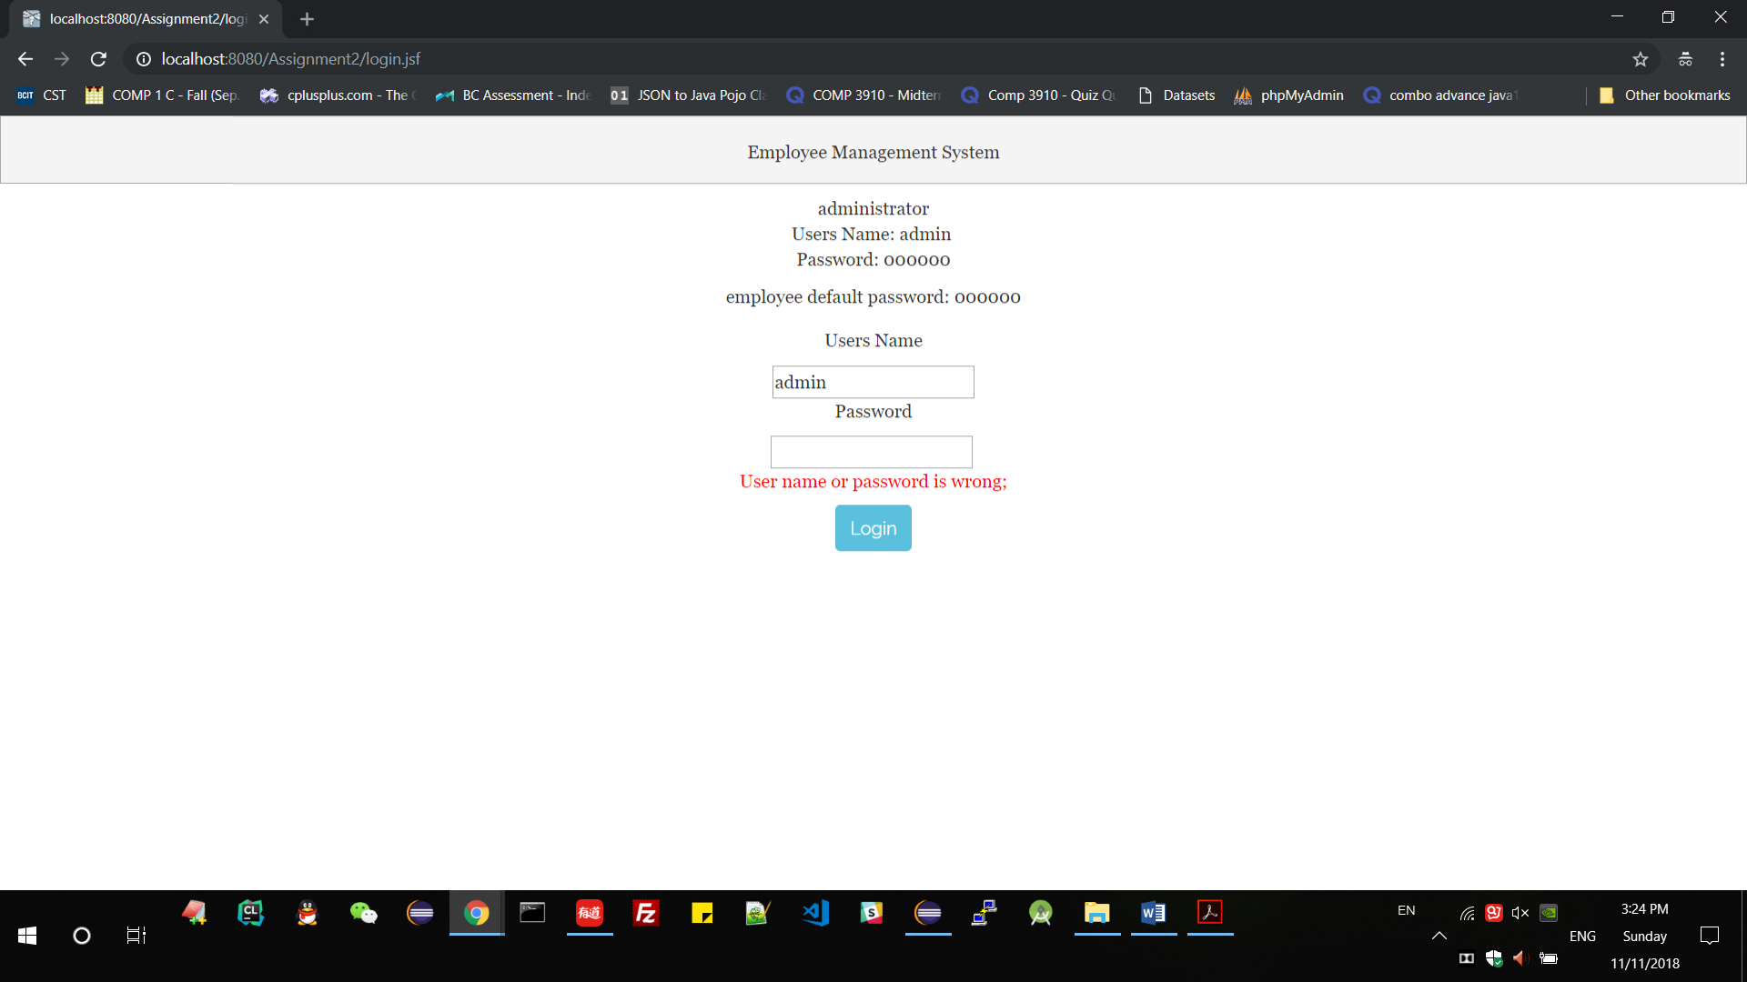 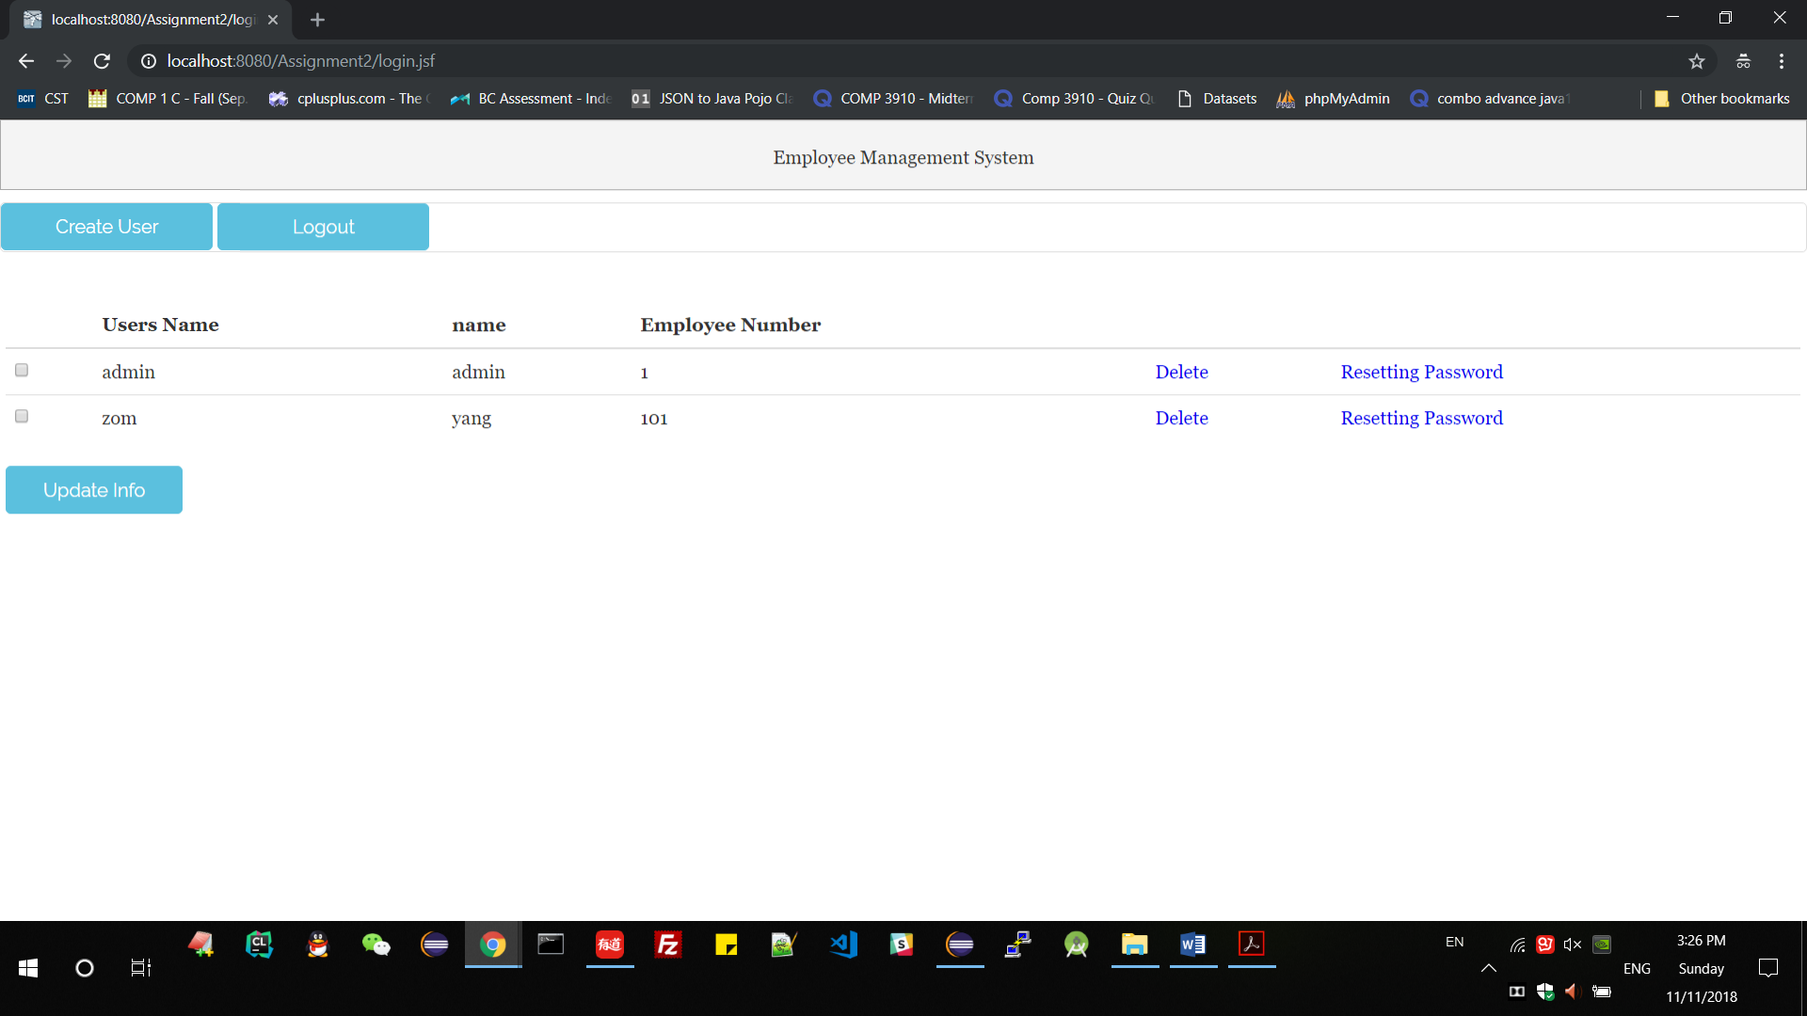

1. Login as employee

Password is wrong-login failed Password is right-Login success

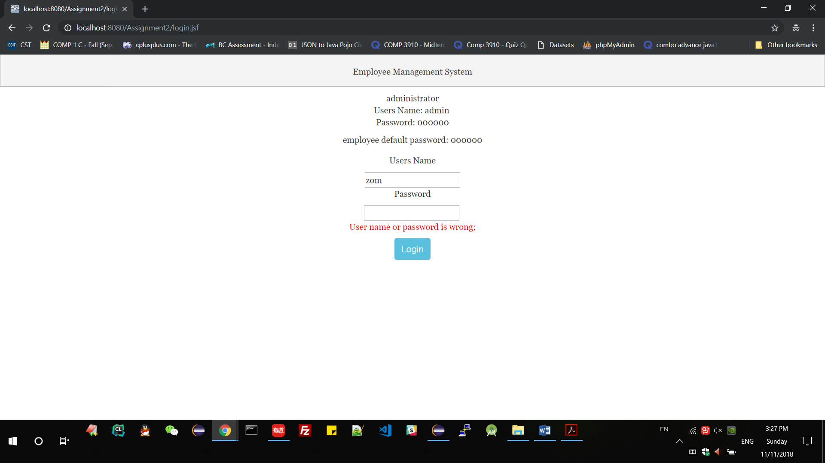 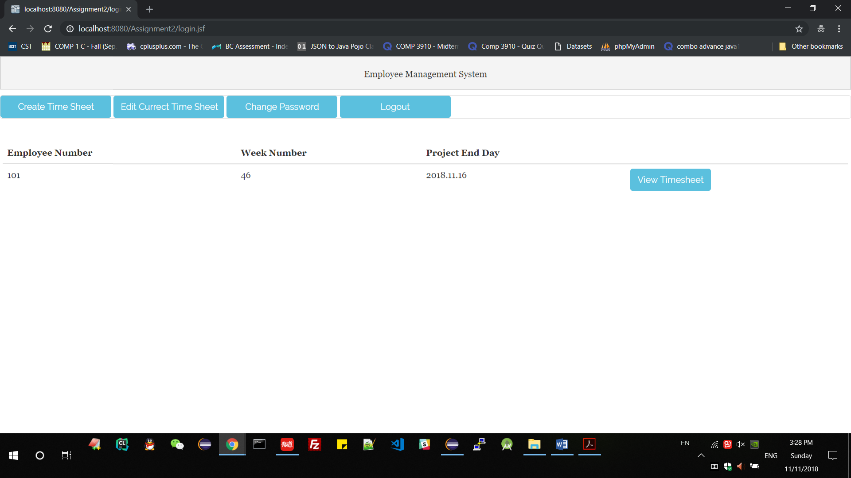

1. create new users
2. When user name or emp Number already exist, create failed

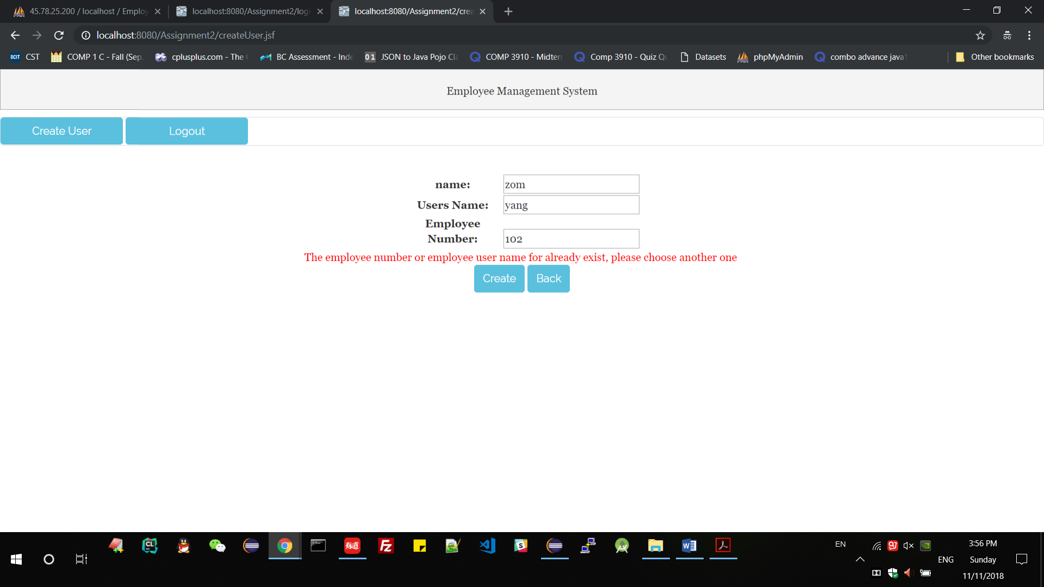

1. When user name already exist, create failed

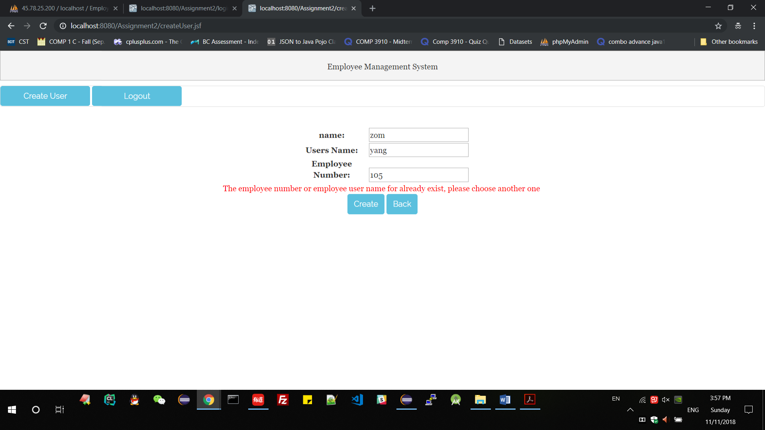

1. When emp Number already exist, create failed

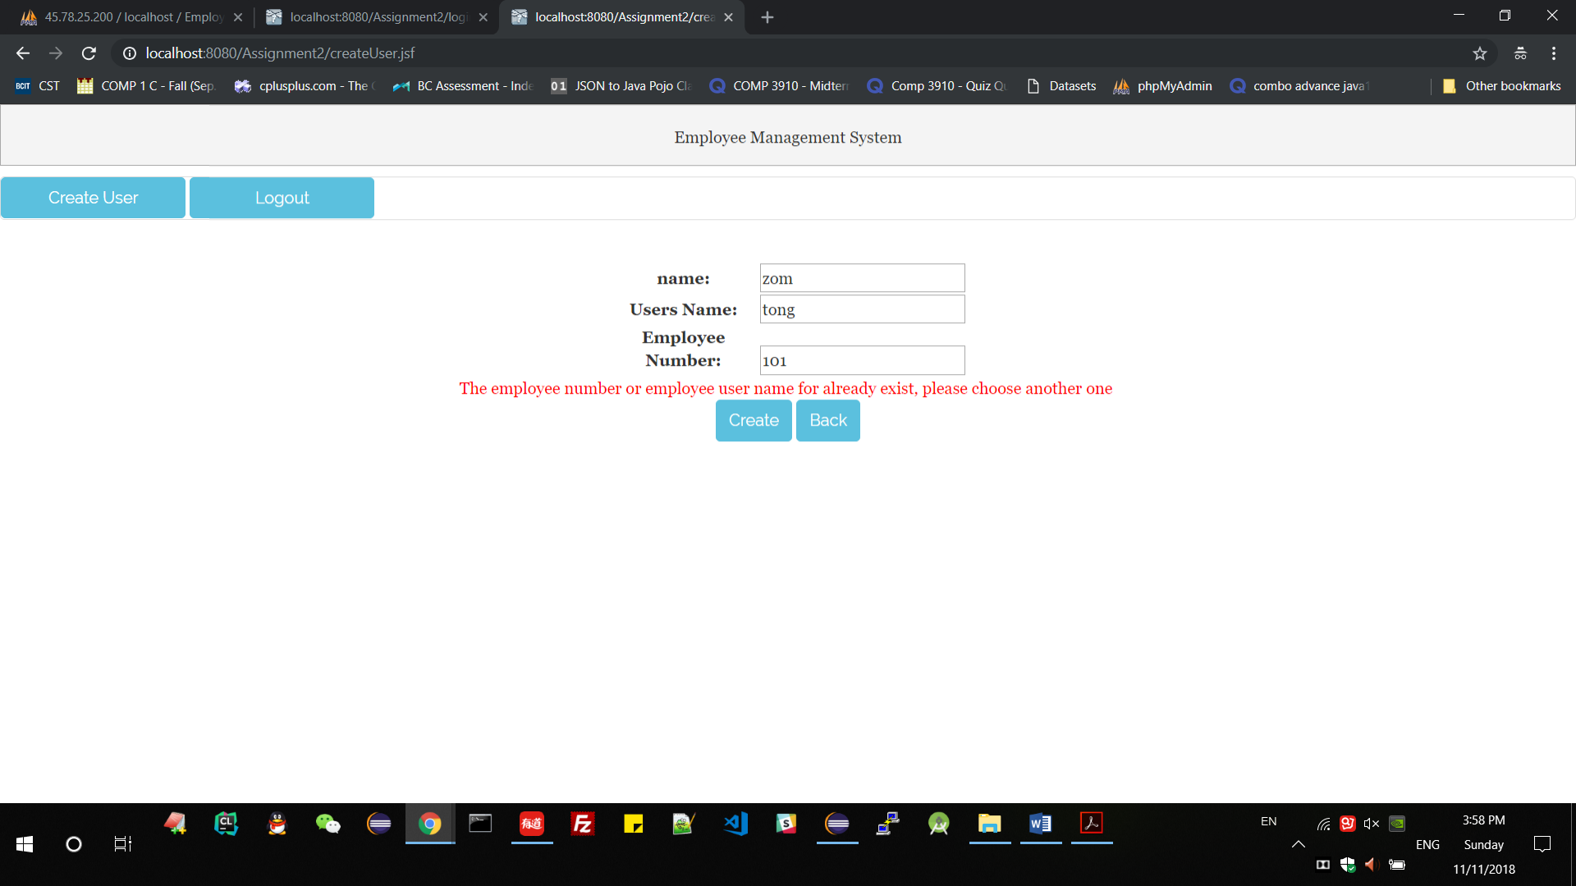

1. Create success when user name and emp Number are unique

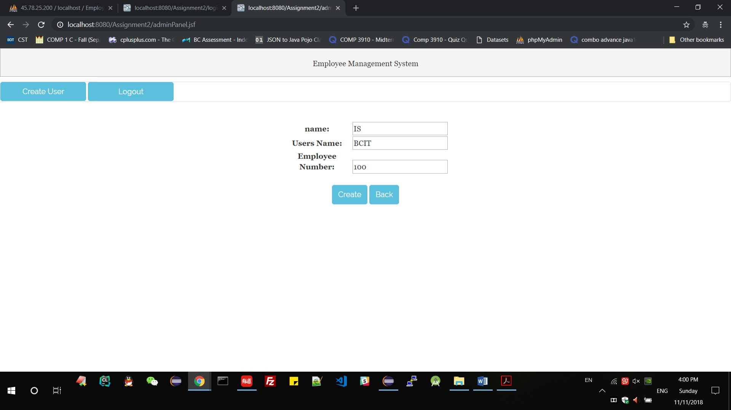 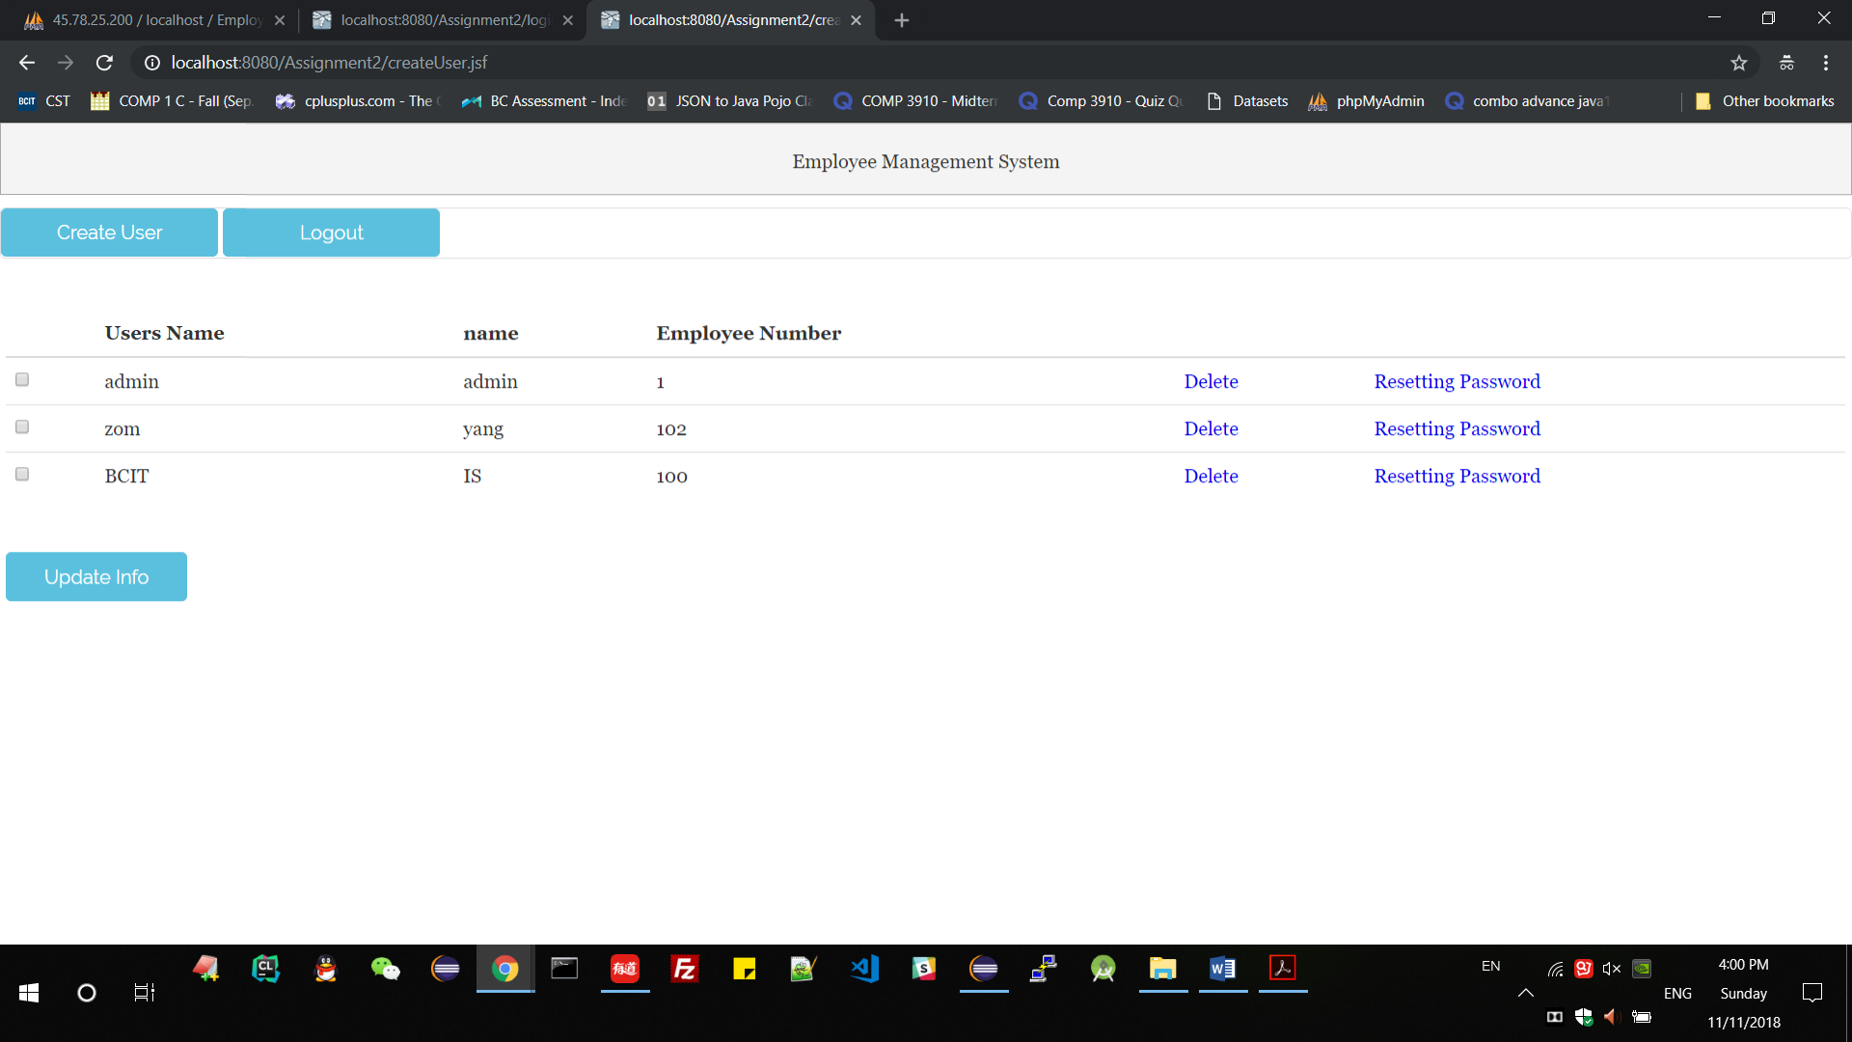

1. edit users

a. When emp Number already exist, create failed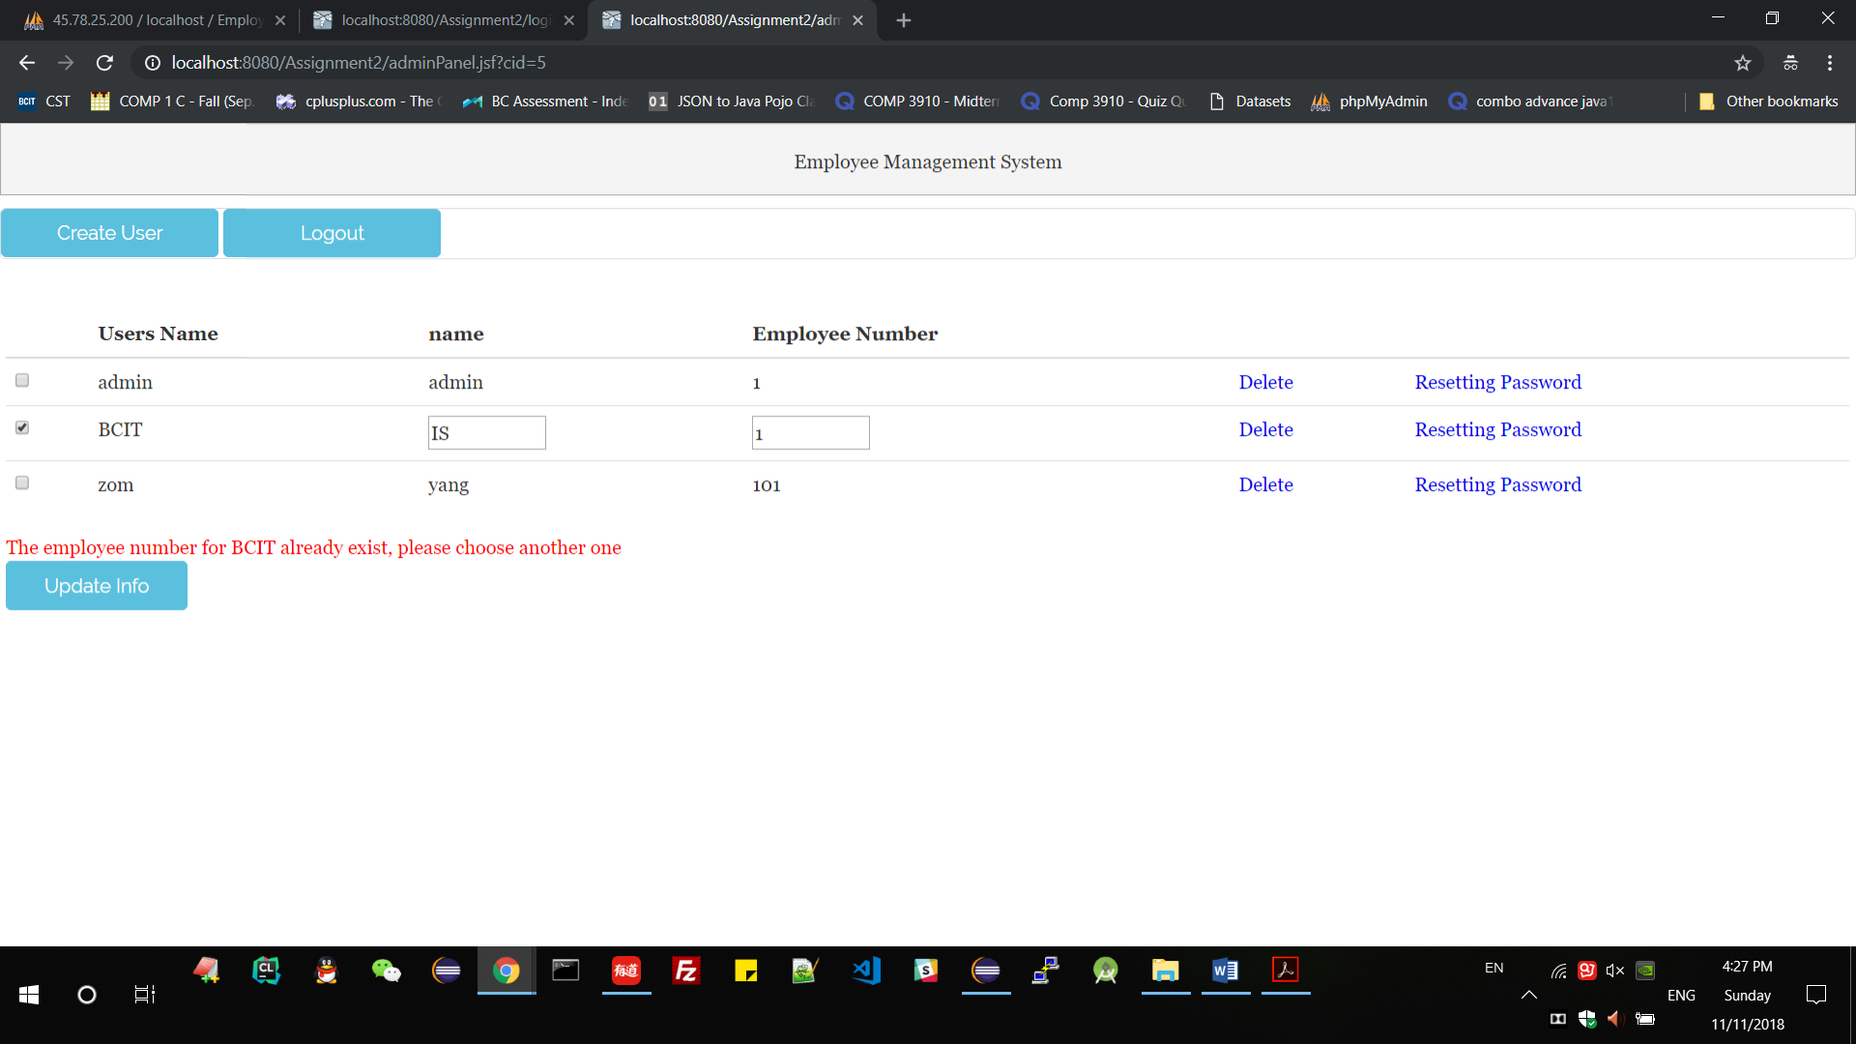

b. Edit success for BCIT the employee number is unique. Check the database date- correct.

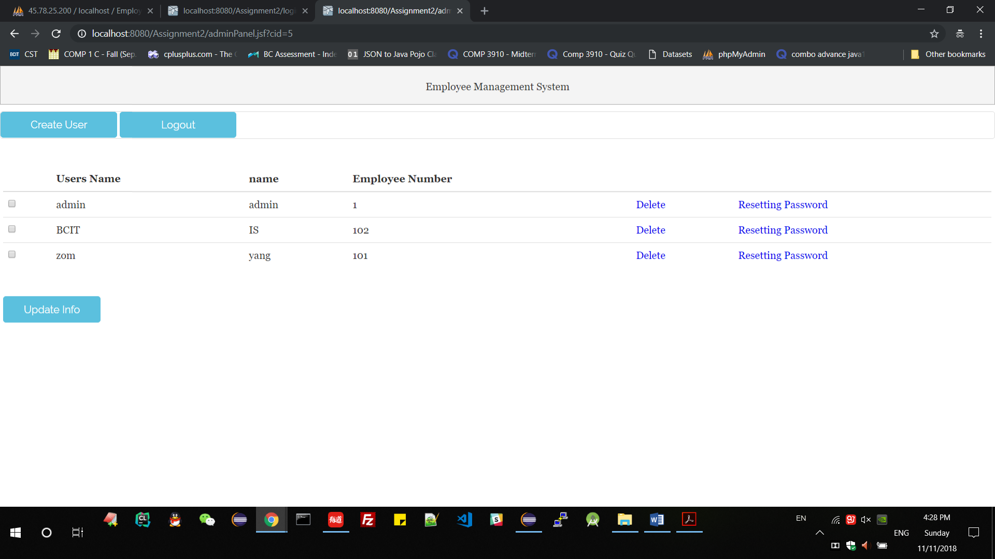

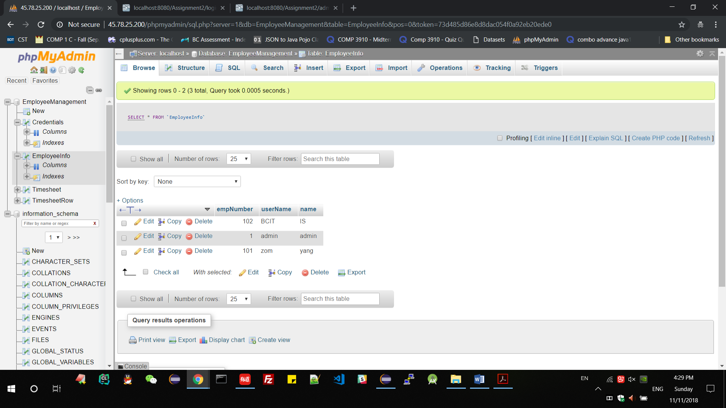

1. delete users
2. admin can not be deleted

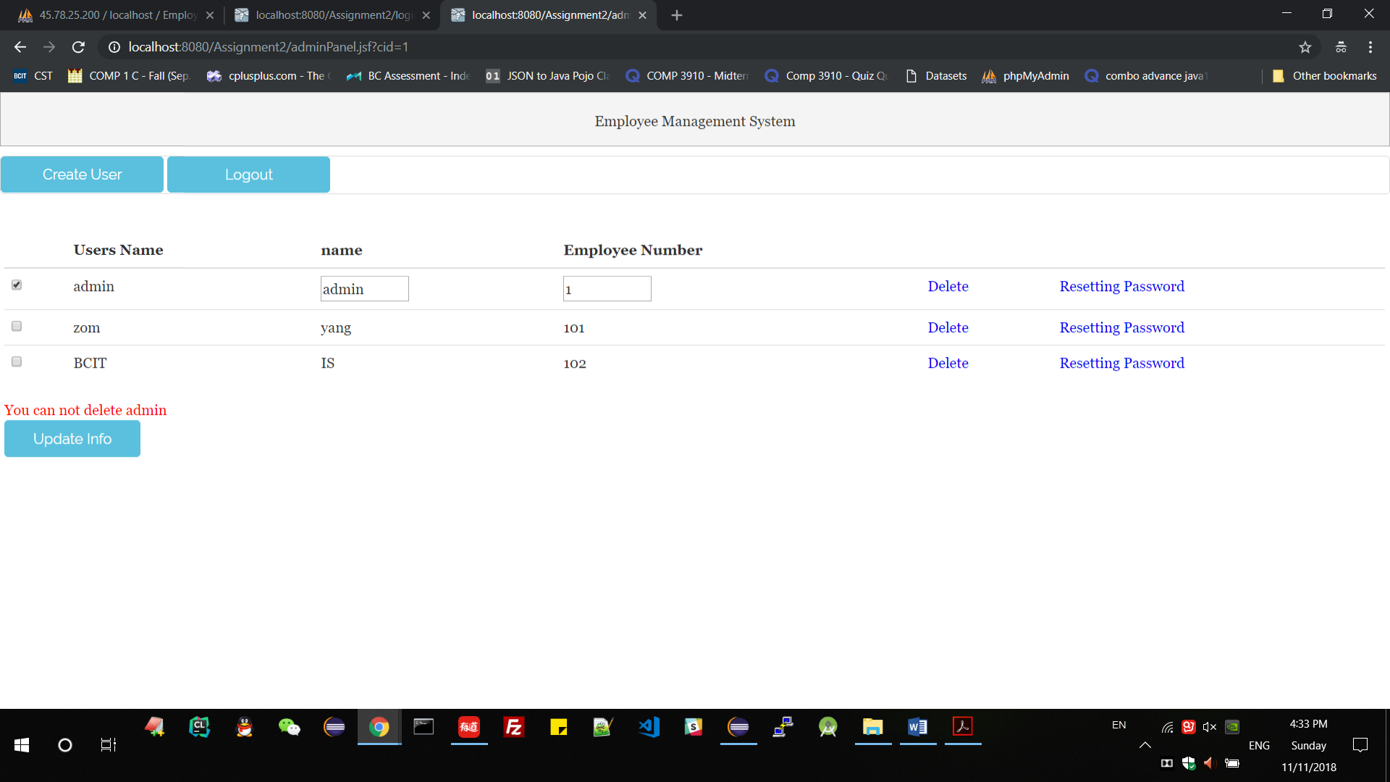

1. other employee can be delete

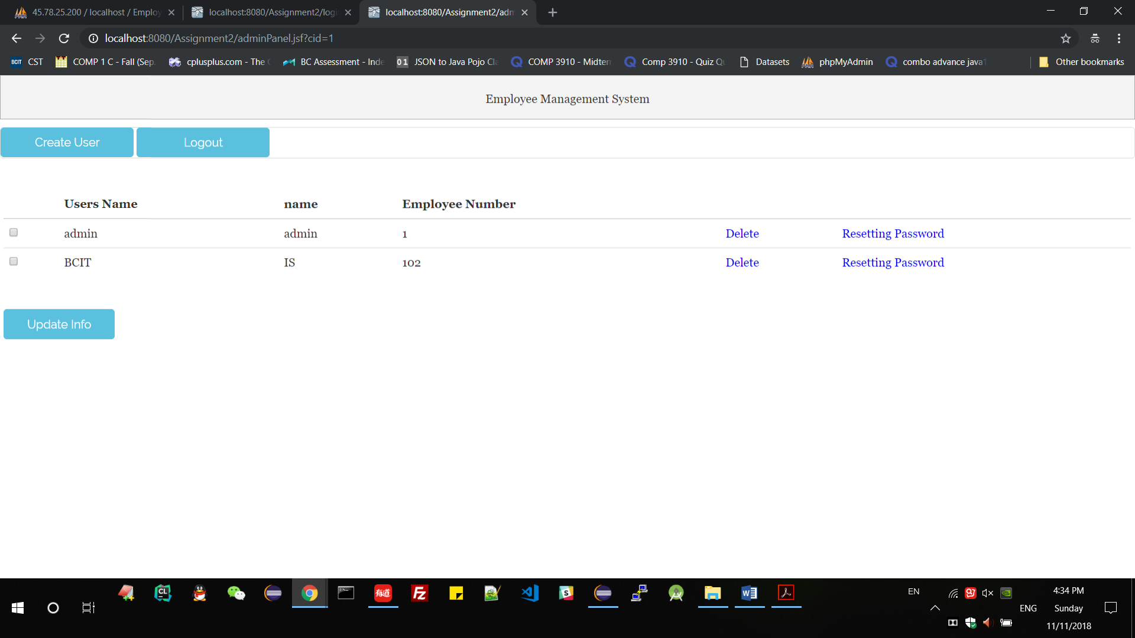

Check database

Table EmployeeInfo Table [Credentials](http://45.78.25.200/phpmyadmin/sql.php?server=1&db=EmployeeManagement&table=Credentials&pos=0&token=73d485d86e8d8dac054f0a92eb20ede0)

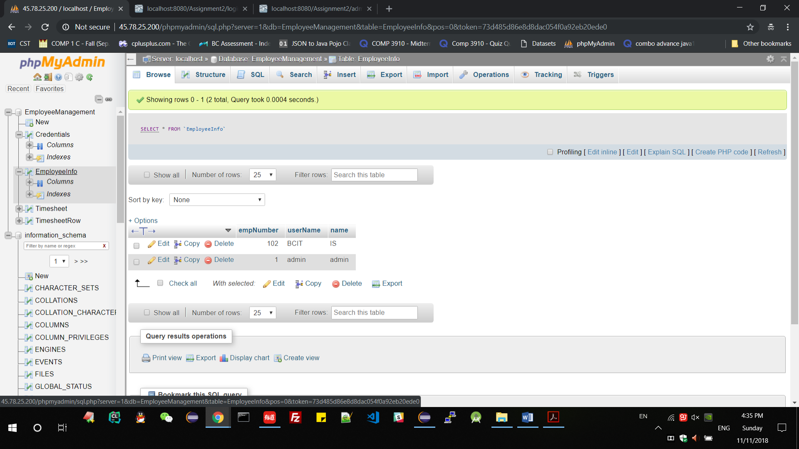 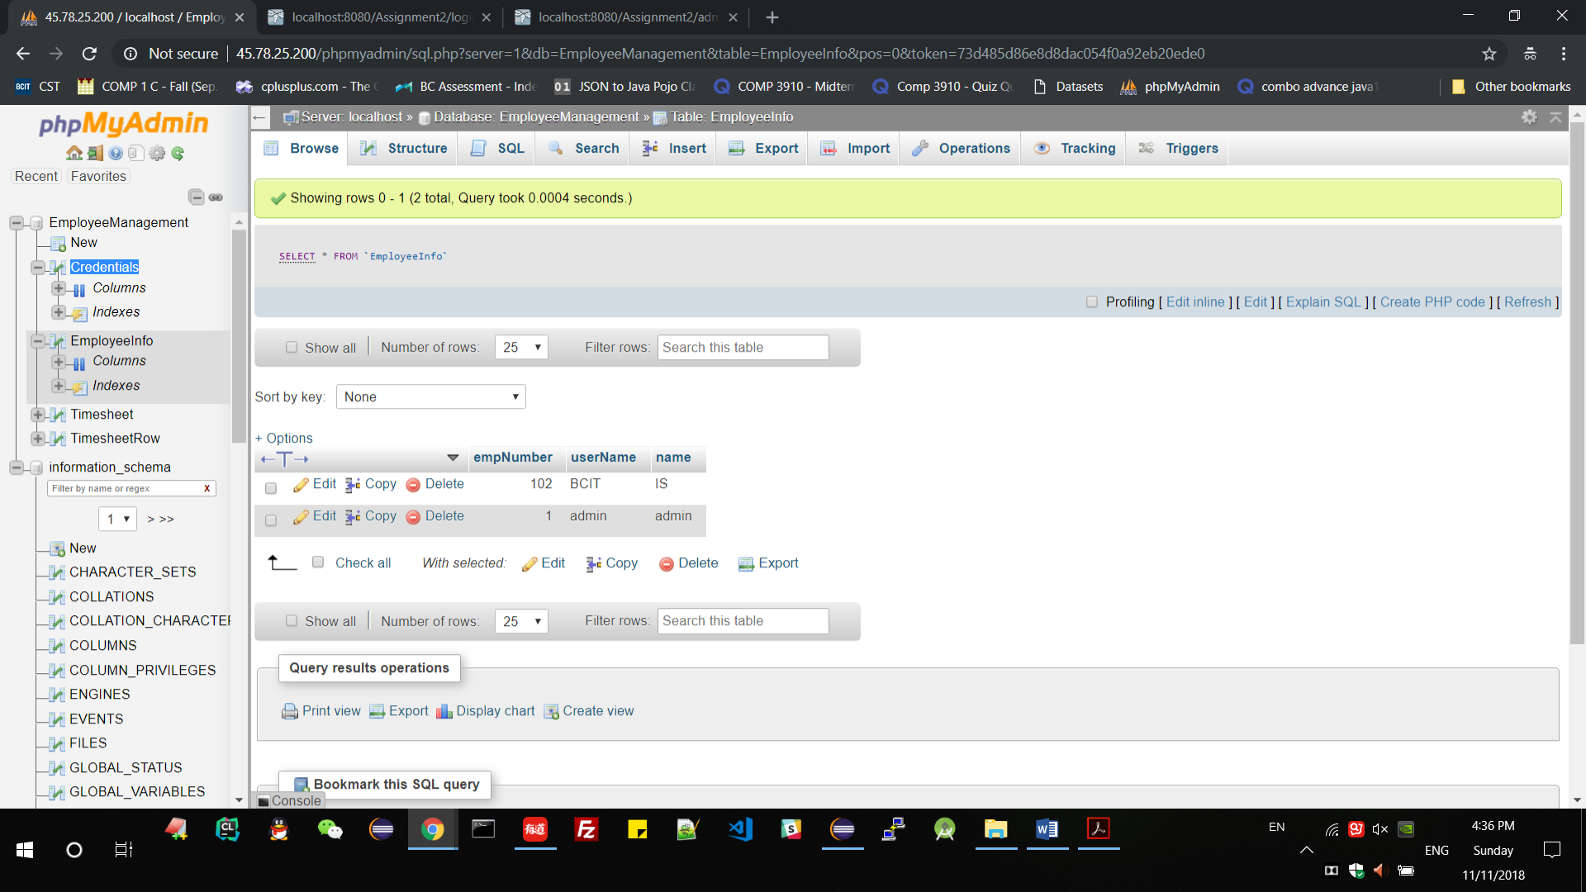

zom is deleted, and admin is still existing.

1. logout

Logout – back to login page and conversation end.

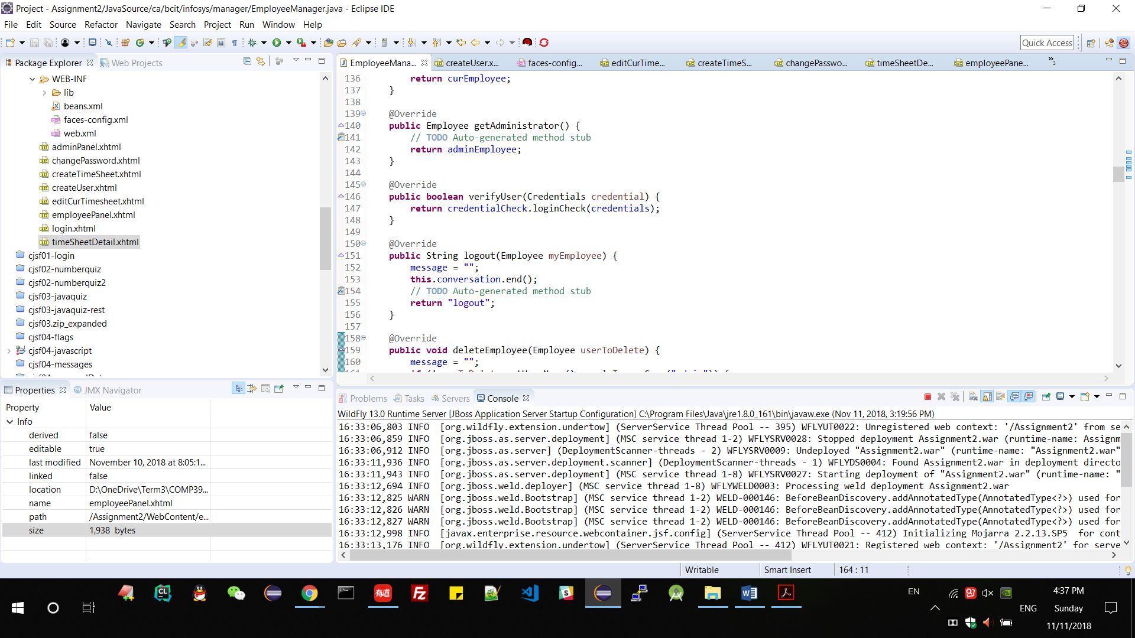

1. Login as user

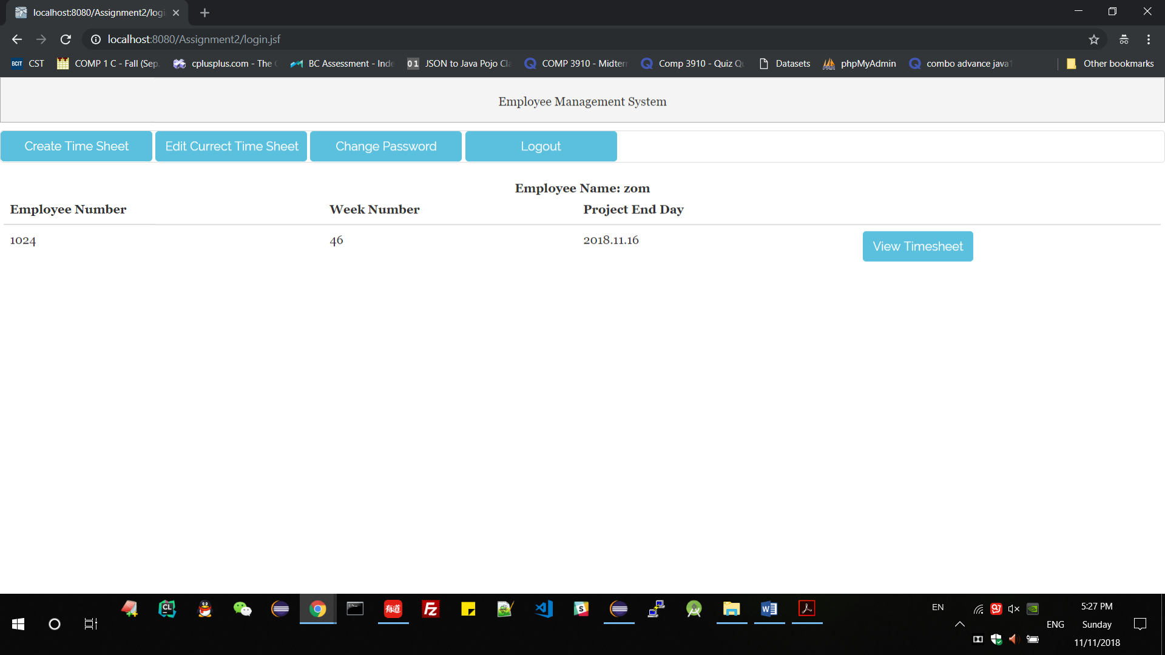

1. create timesheet
2. project and wp can not be null

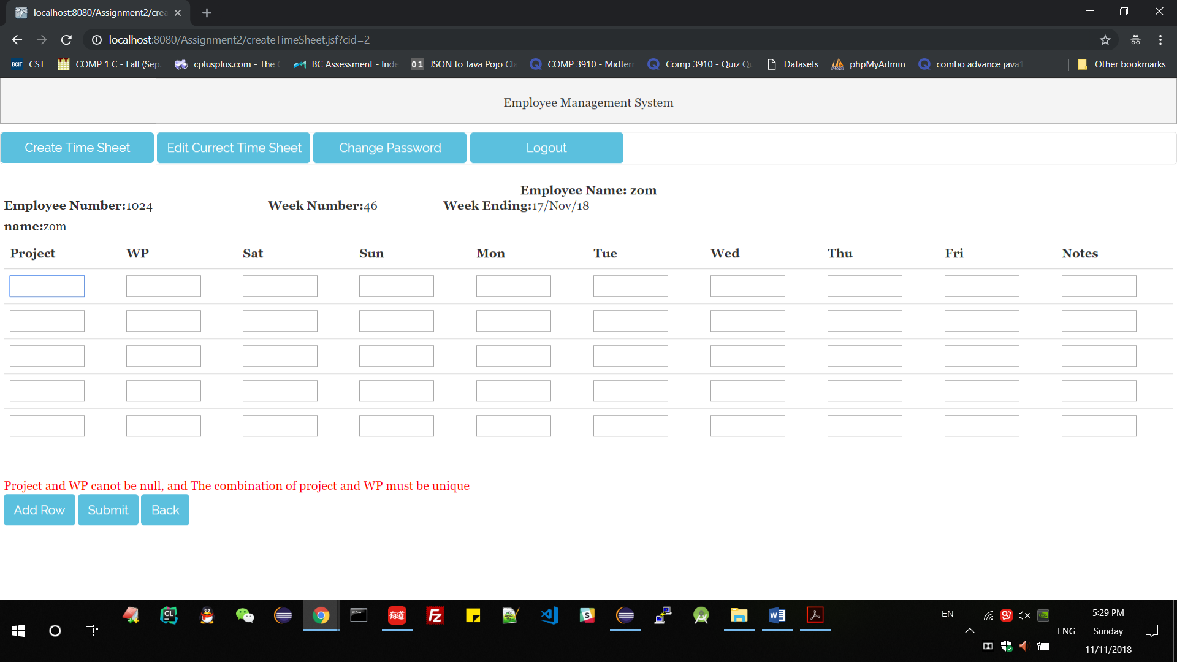

1. The combination of project and WP are not unique

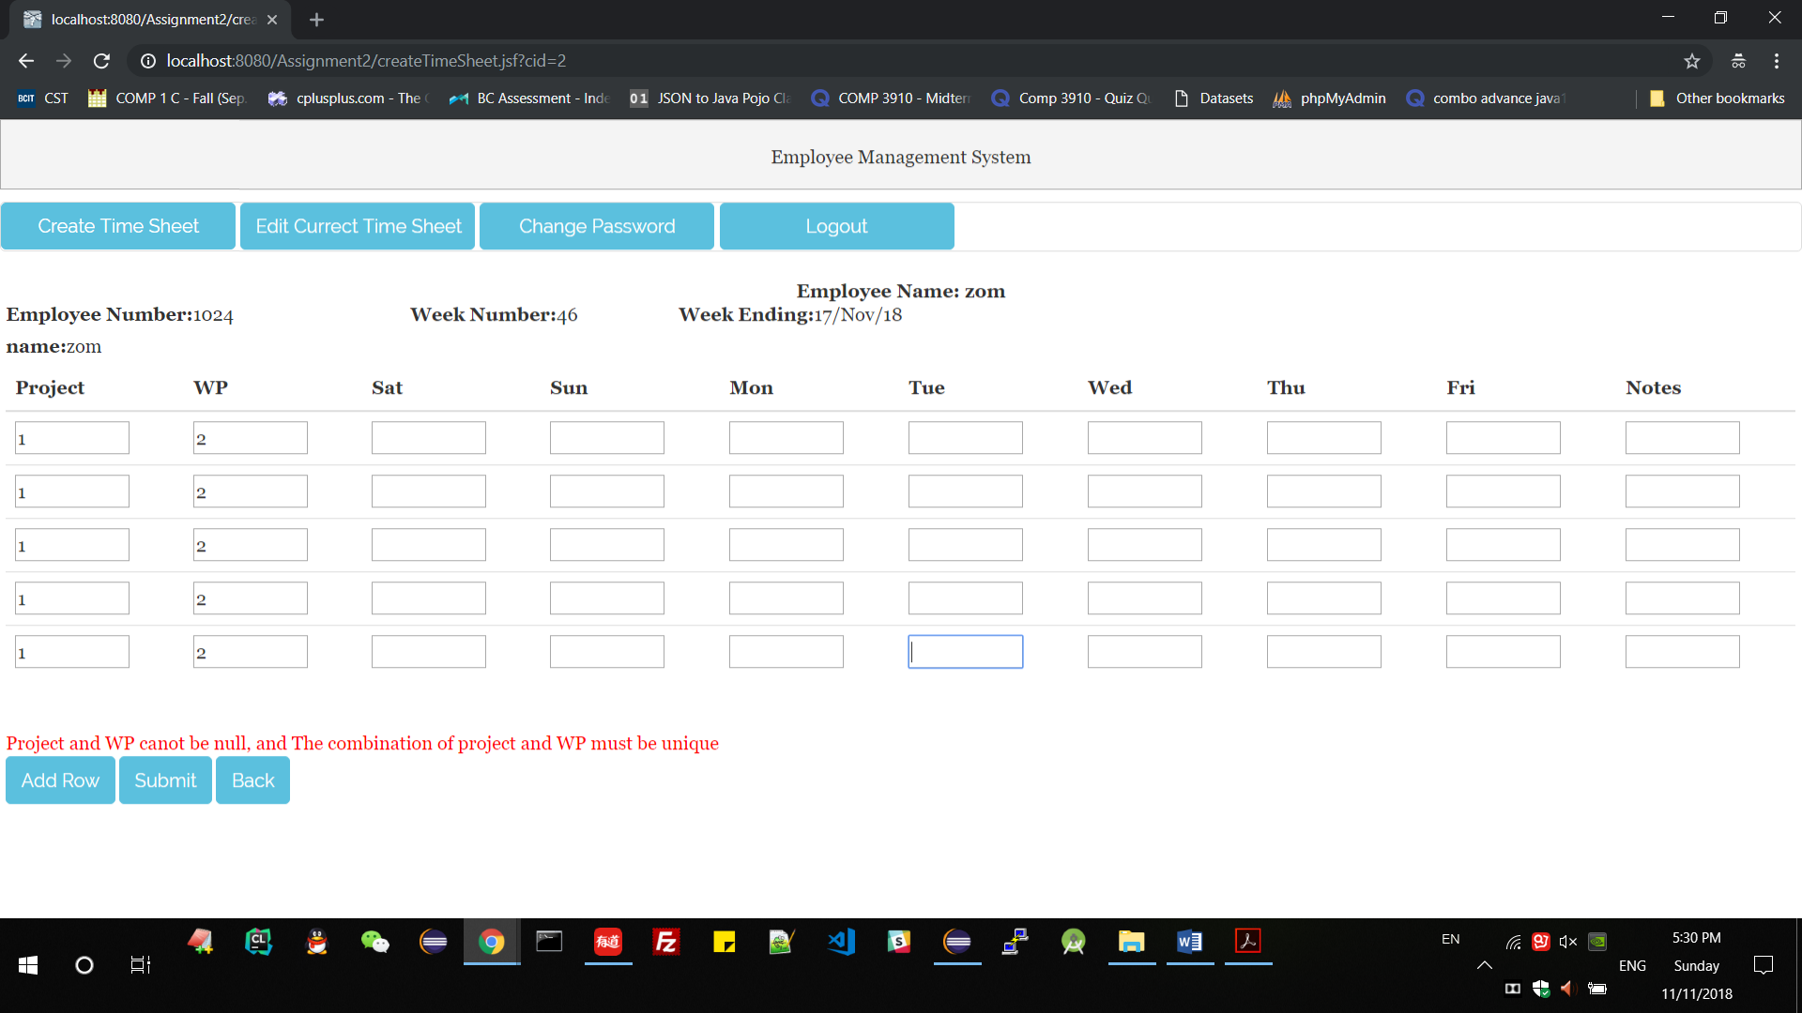

1. The hour from sat to fri must between 0 – 24

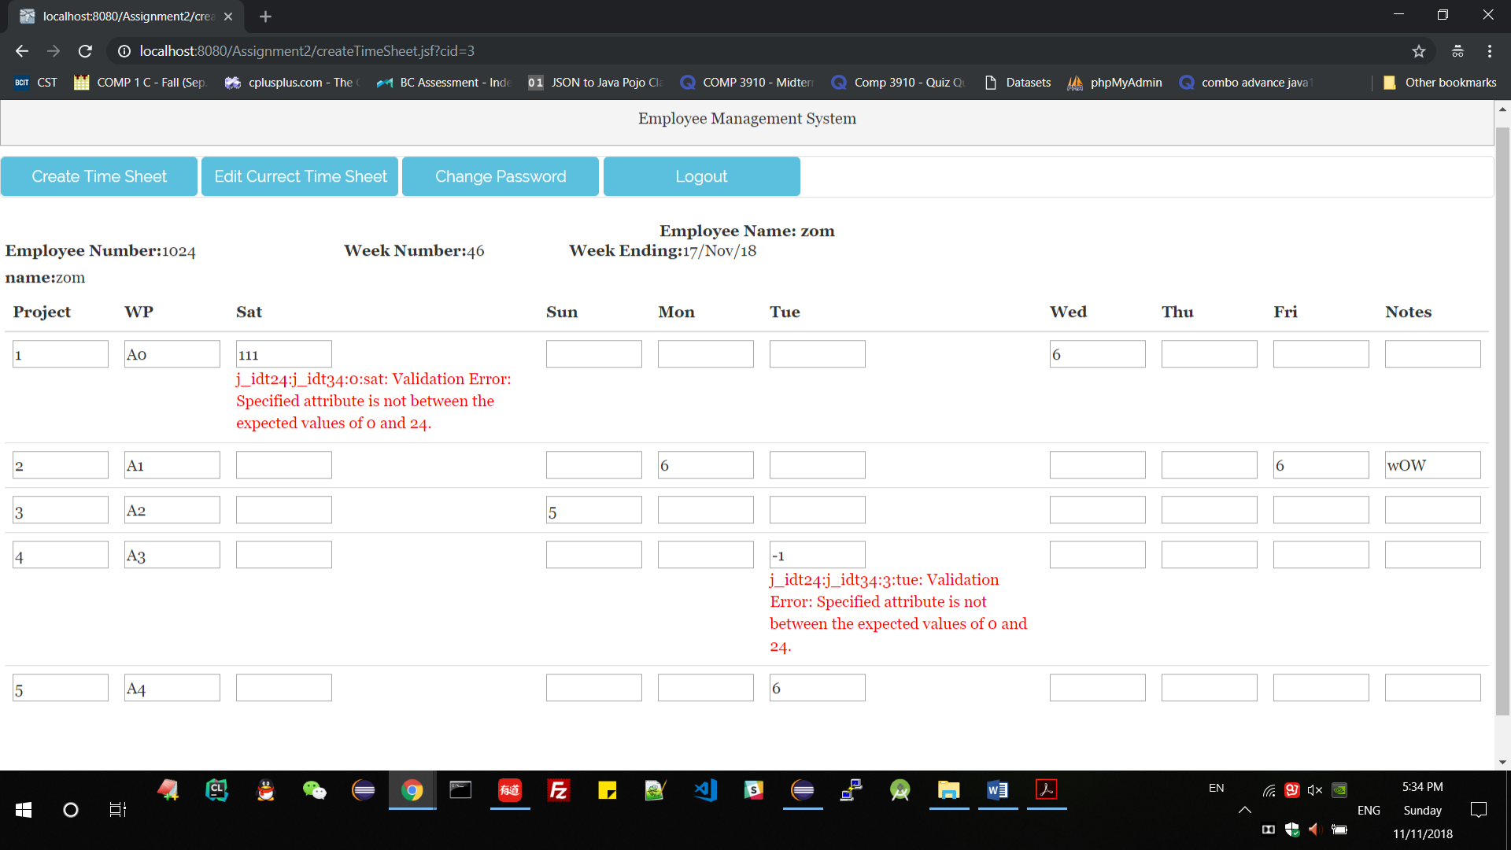

1. Create success, the one line is timesheet just created.

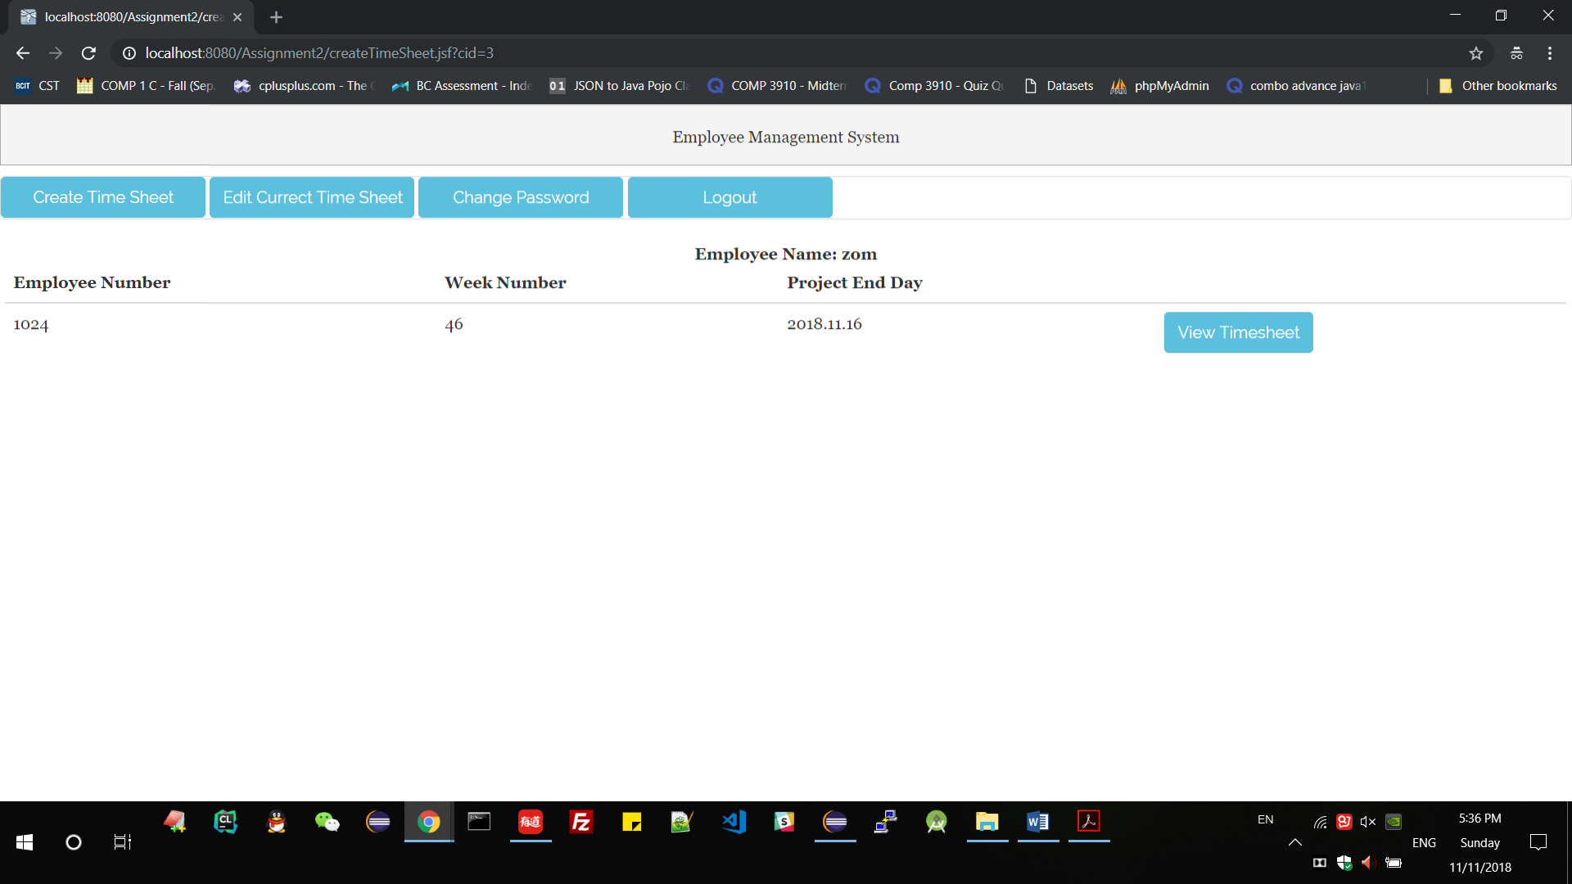

1. edit each timesheet
2. edit the current timesheet

Show the current timesheet first.

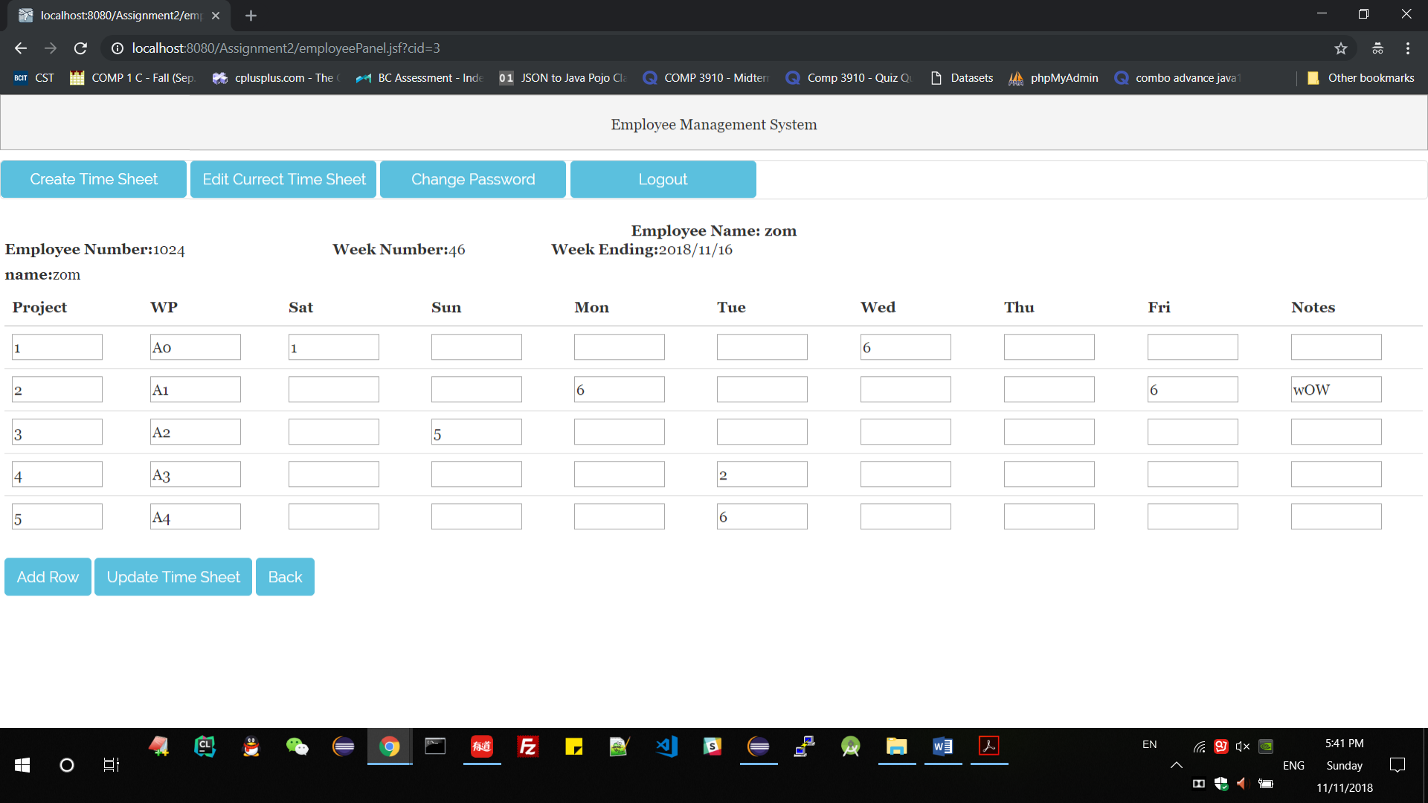

Edit one row and edit line 5

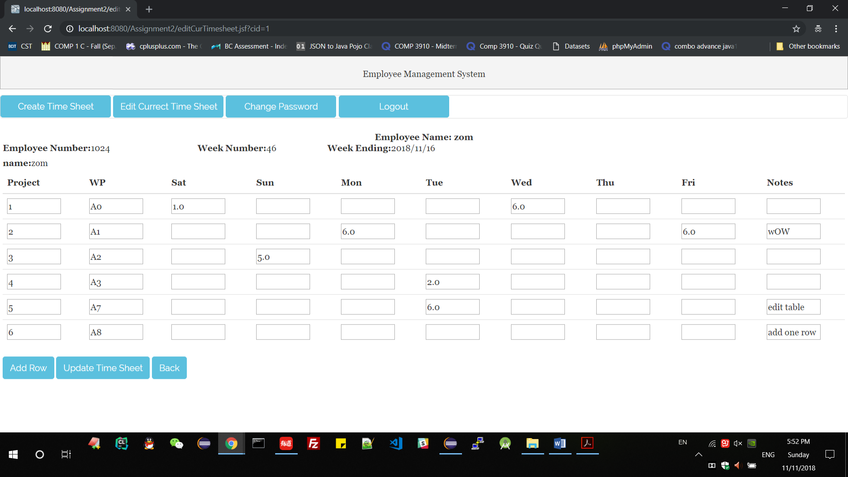

View timesheet details-edit success.

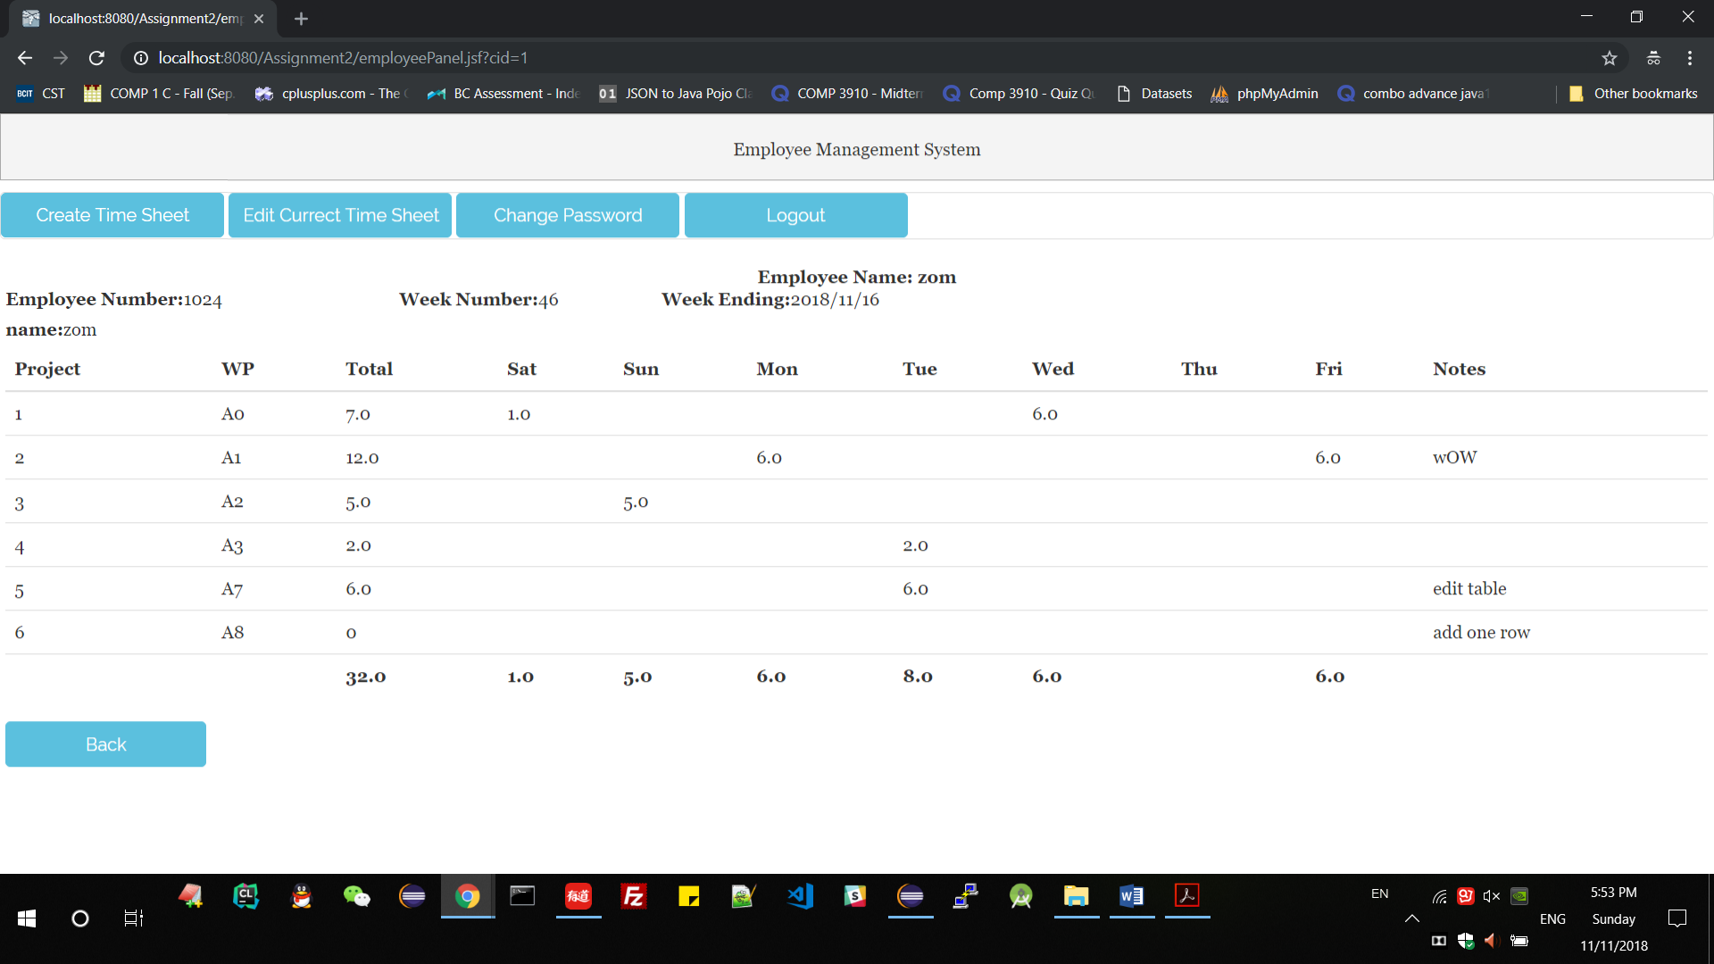

Check the database

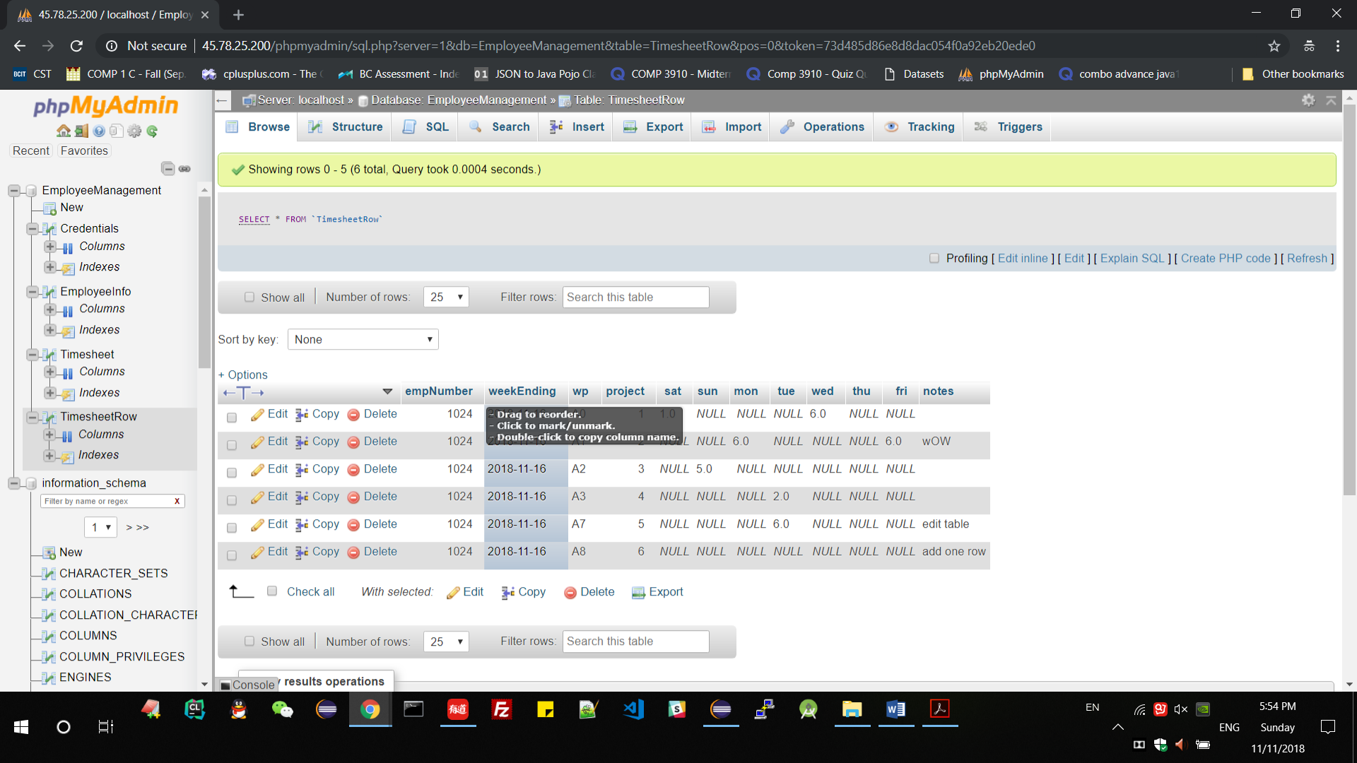

1. the line validation(the hours must between 0 and 24)

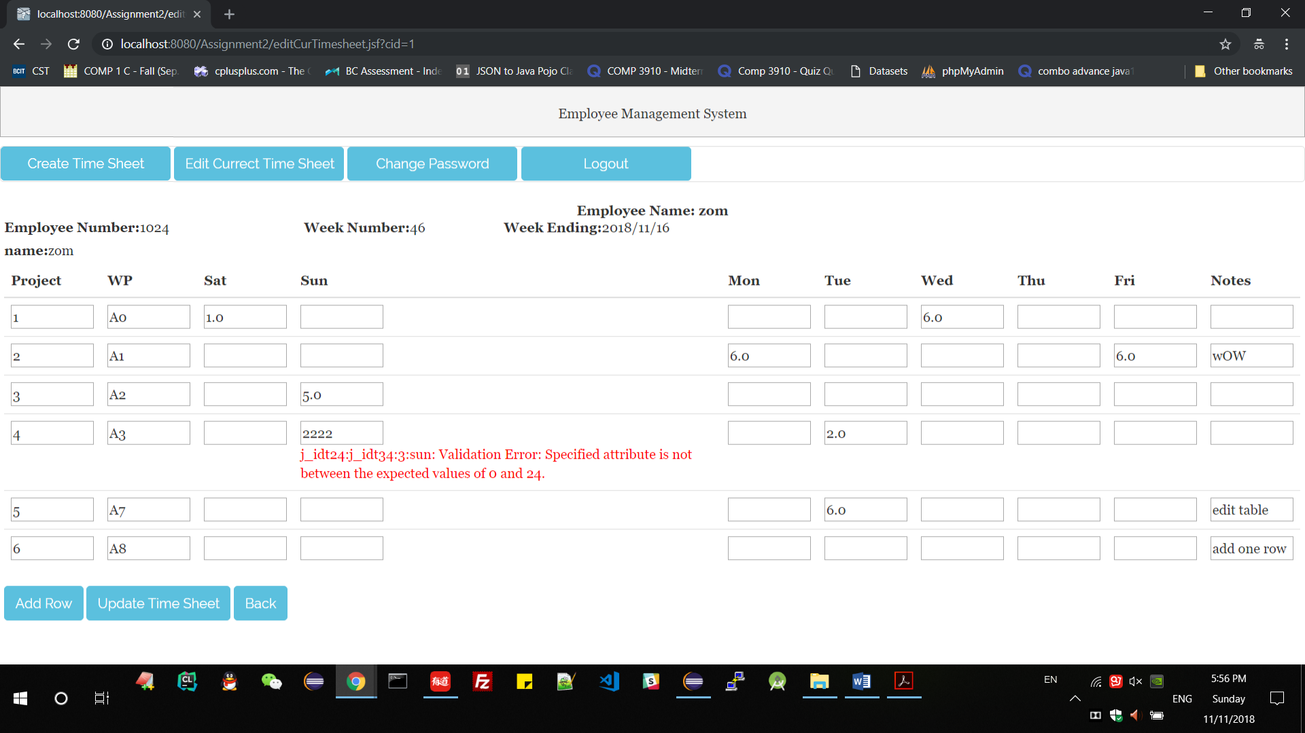

1. add rows when create timesheet(edit timesheet and add row already test below)

Login with other employee with no timesheet

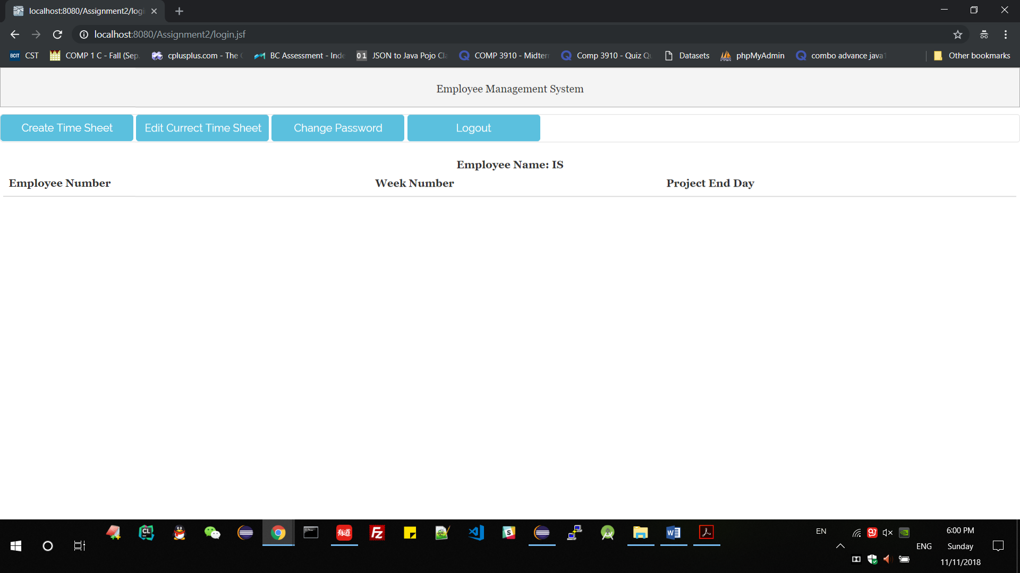  
 add one row which the table will have 6 row

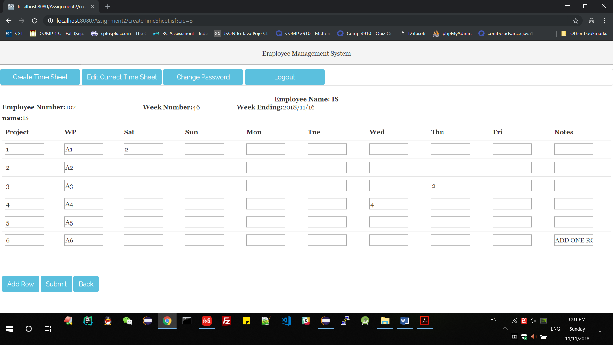

Submit and view detail

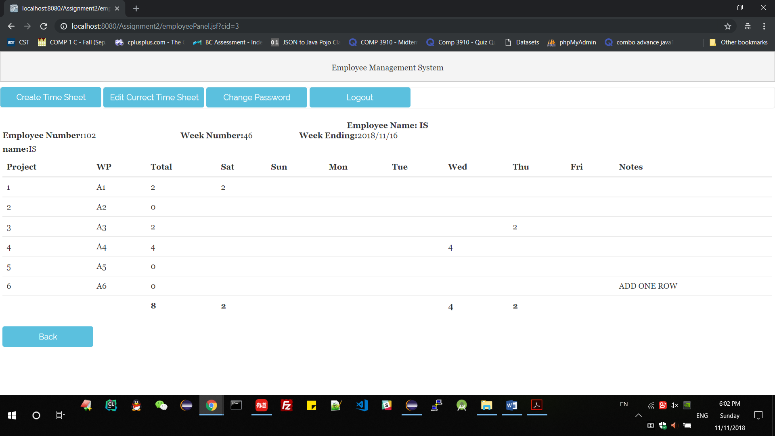

1. check the validator- already test above
2. view timesheet details- already test above
3. employee change password

Change employee BCIT password to 123456, and login again with new password-success

Change employee BCIT password to 123456, and login again with old password-failed

1. admin resetting default password for BCIT

resetting password to 000000, BCIT login with 000000-success, BCIT login with 123456-failed

## Test Results

1. Login as administrator - success
2. create new users - success
3. edit users - success
4. delete users - success
5. log out - success
6. Login as user - success
7. create timesheet - success
8. edit each timesheet - success
9. add rows - success
10. check the validator – success
11. view timesheet details – success
12. employee change password – success
13. admin resetting password as default password-success

## database setting

SQL file name is EmployeeManagement.sql

Run the script in Database commend line(I use phpmyadmin)

I deployed the database on the VPS server which also can test the assignment using below information.   
The connection URL jdbc:mysql://45.78.25.200:3306/EmployeeManagement  
User Name: manager  
Password: manager  
JNDI Name java:jboss/datasources/EmployeeManagement

Datasource mappedName:  
@Resource(mappedName = "java:jboss/datasources/EmployeeManagement")

**private** DataSource ds;

## Instructions for Building and Running

1. Extract the zipped project
2. Open eclipse
3. Click File - > Open Projects from File Systems
4. Click Directory - > choose the extracted folder in first step - > finish
5. Double Click the server to start it
6. Rightclick WebContent/ login.xhtml -> Run On Server -> OK